

Build & Configure Small Network

Task 2 Assessment

by dhamarlou bowen – Student ID = 20123076

Year 1

Contents

Developing Addressing Scheme 2

Configuring Device IP Address & Security Settings 3

Testing & Verification of IPv4/IPv6 End-to-End Connectivity 12

**Topology & Allocated Network Address:** **192.168.69.0/24**



# Developing Addressing Scheme

Develop an addressing scheme for two subnets A & B:

* Subnet A = 31 Hosts Required
* Subnet B = 63 Hosts Required

**VLSM Subnet Calculation**

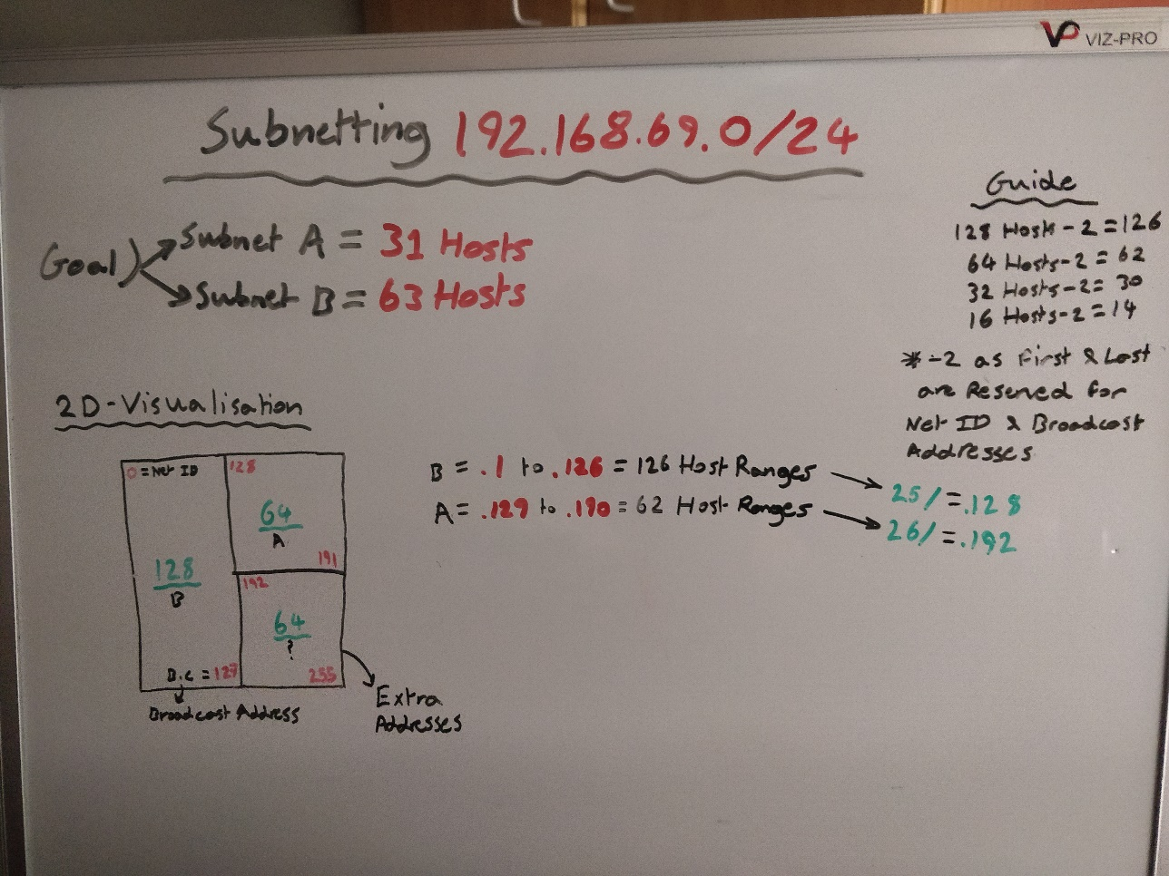The image below (**Figure 1.0**) display the calculation of the desired subnetting scheme through the use of a whiteboard. I used the 2D visualisation method to calculate the appropriate host ranges that would be suitable to each subnet. As subnet B was the largest, it is prioritised first. With a host range of 63 being required this is too large for a 64-host subnet mask that technically has 62 hosts available when 2 addresses are reserved for the Net ID & Broadcast address. This led to the 128-subnet mask being used as it provides a suitable range. The same can be said subnet B with 31 hosts. Once suitable subnet masks were calculated, there is also additional address space leftover that can be found in the bottom right side of the 2D visualisation below.

**(Fig 1.0)**

IP Addressing Table Below:

| Specification | Subnet A | Subnet B |
| --- | --- | --- |
| Subnet address | 192.168.69.128 | 192.168.69.0 |
| Number of usable hosts per subnet | 62 | 126 |
| Broadcast address | 192.168.69.191 | 192.168.69.127 |

Subnetting Assignment Table Below:

| Device | IP address | Subnet Mask | Gateway |
| --- | --- | --- | --- |
| PC-A | 192.168.69.190 | 255.255.255.192 | 192.168.69.129 |
| R1-G0/0/0 | 192.168.69.1 | 255.255.255.128 | *N/A* |
| R1-G0/0/1 | 192.168.69.129 | 255.255.255.192 | *N/A* |
| S1 | 192.168.69.130 | 255.255.255.192 | 192.168.69.129 |
| PC-B | 192.168.69.126 | 255.255.255.128 | 192.168.69.1 |

IPv6 Addressing Table Below:

| Device | IPv6 address | Prefix Length | Gateway |
| --- | --- | --- | --- |
| R1-G0/0/0 | 2001:db8:acad:0002::1 | /64 | *N/A* |
| R1-G0/0/1 | 2001:db8:acad:0001::1 | /64 | *N/A* |
| S1 | 2001:db8:acad:0001::2 | /64 | 2001:db8:acad:0001::1 |

# Configuring Device IP Address & Security Settings

Step 1: Configuration Intermediary Devices

* 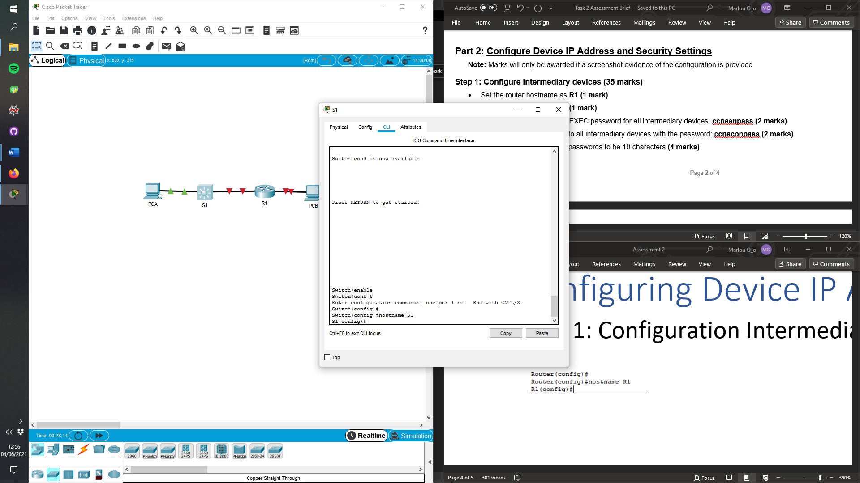Setting Router & Switches names

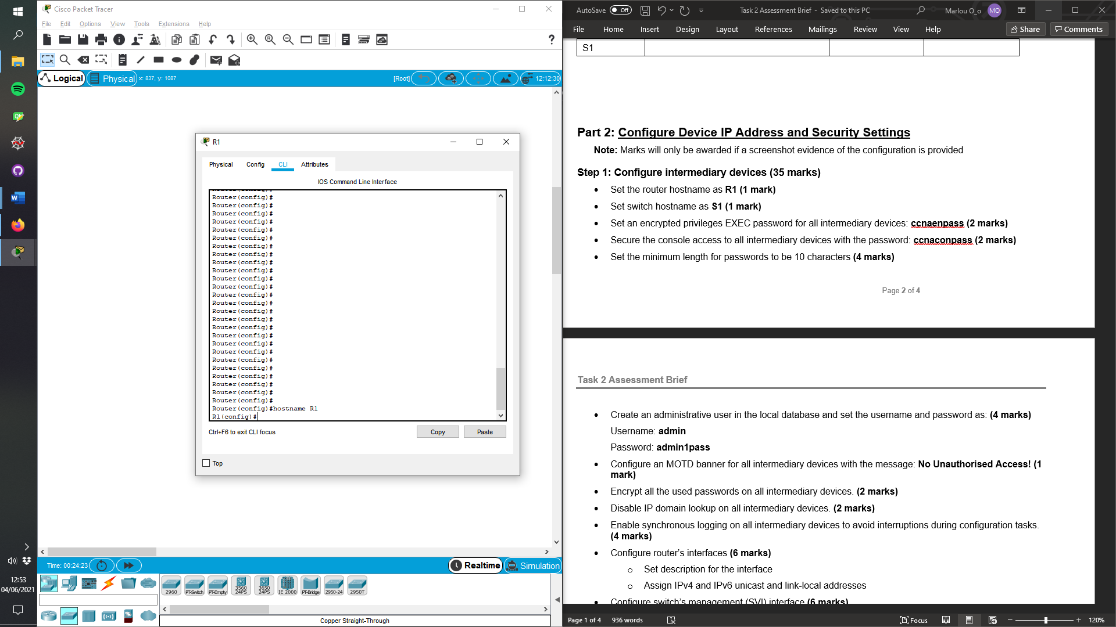

* 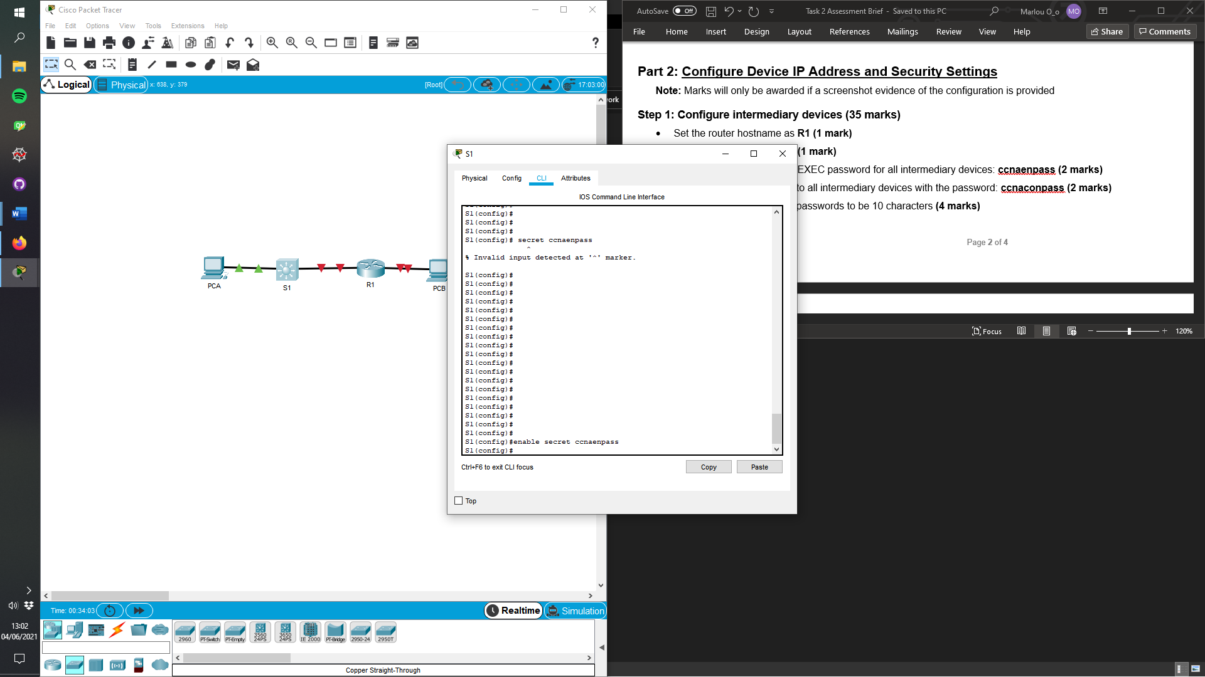 EXEC Passwords

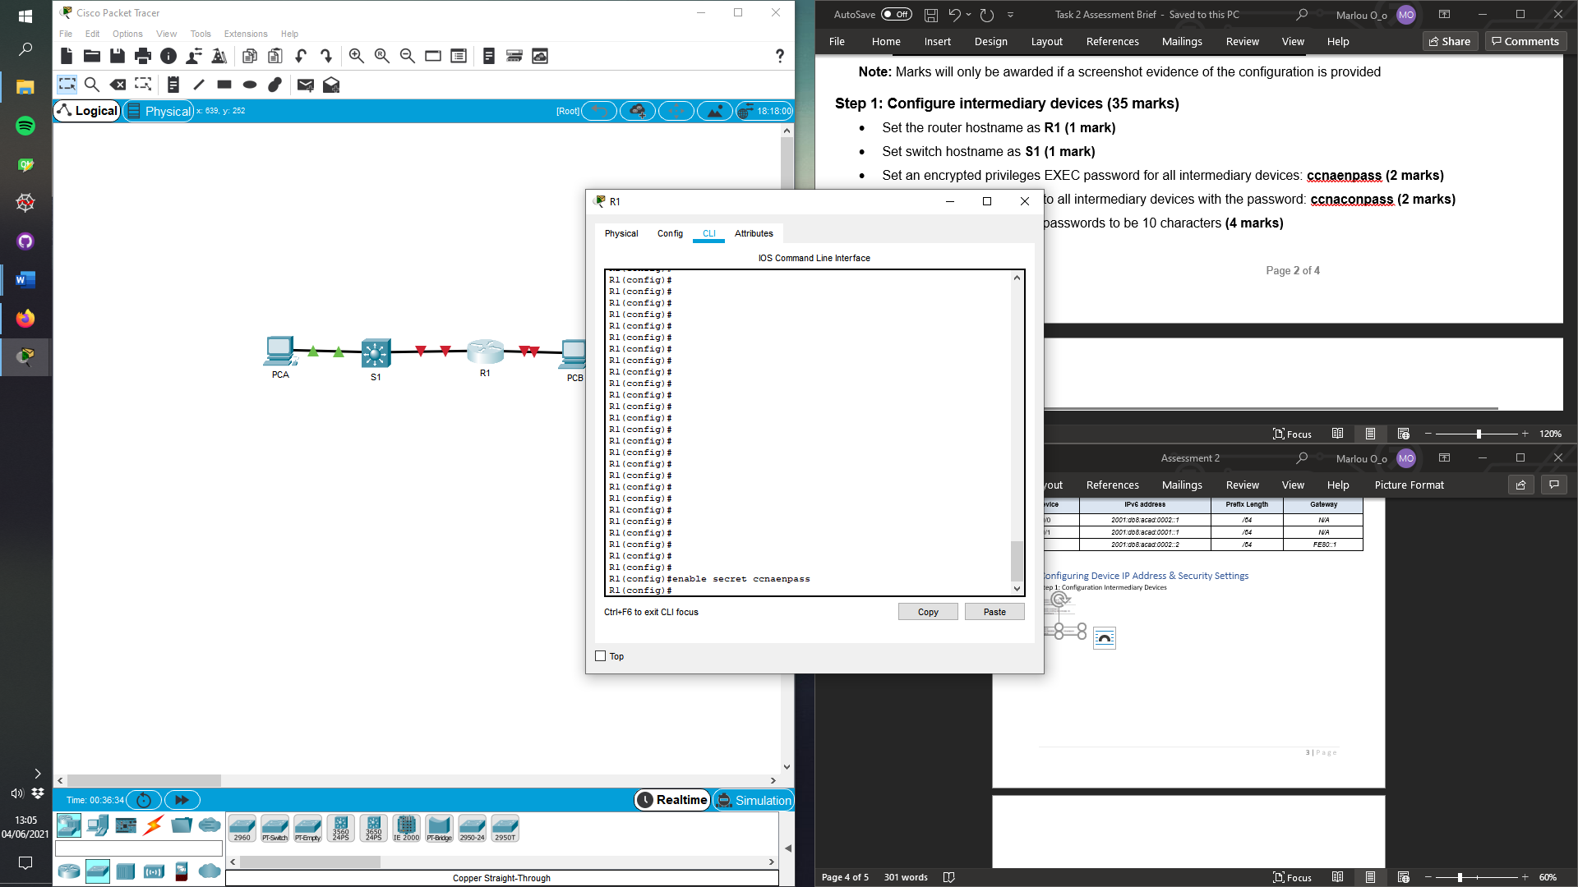

* 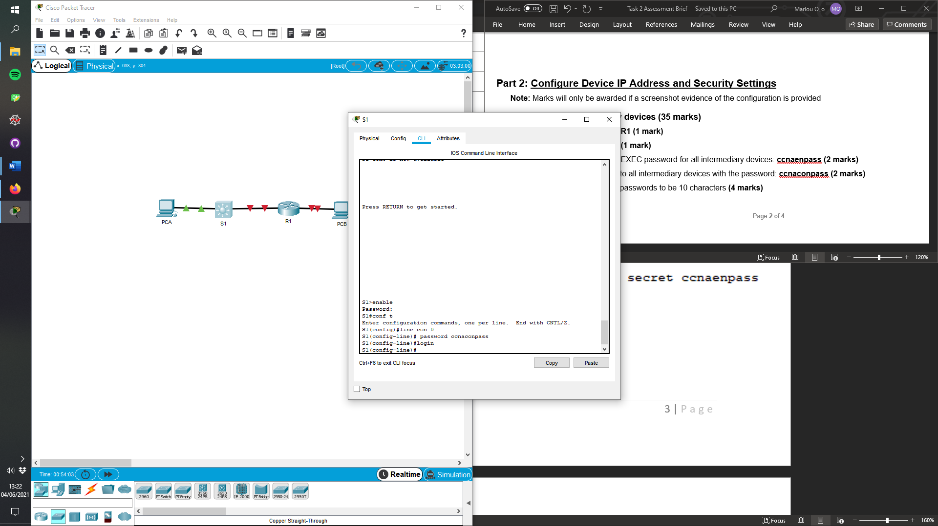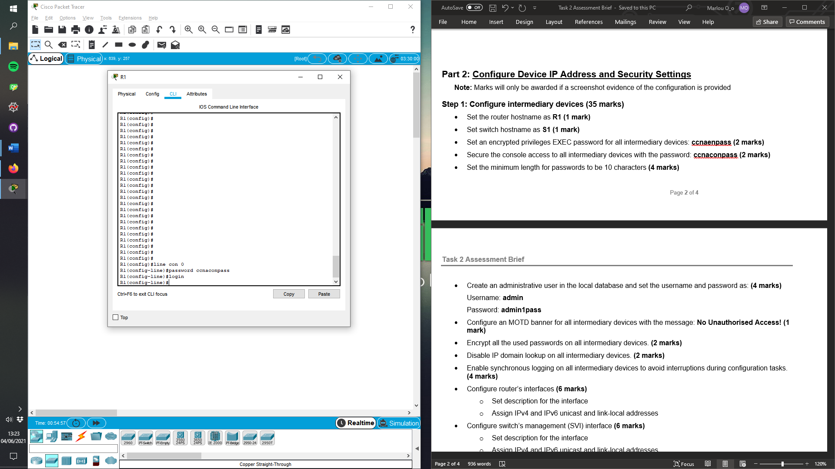Console Passwords
* 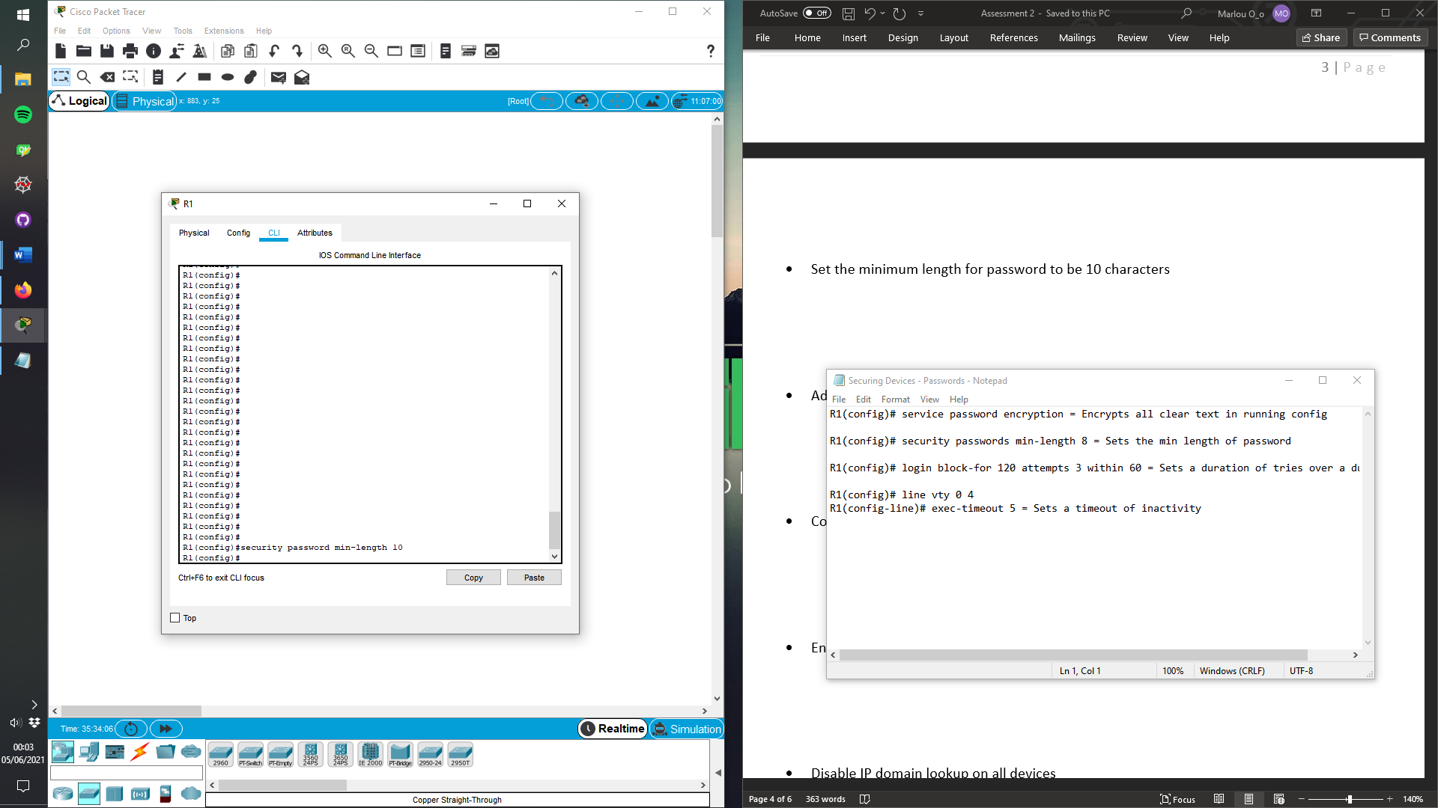Set the minimum length for password to be 10 characters
* 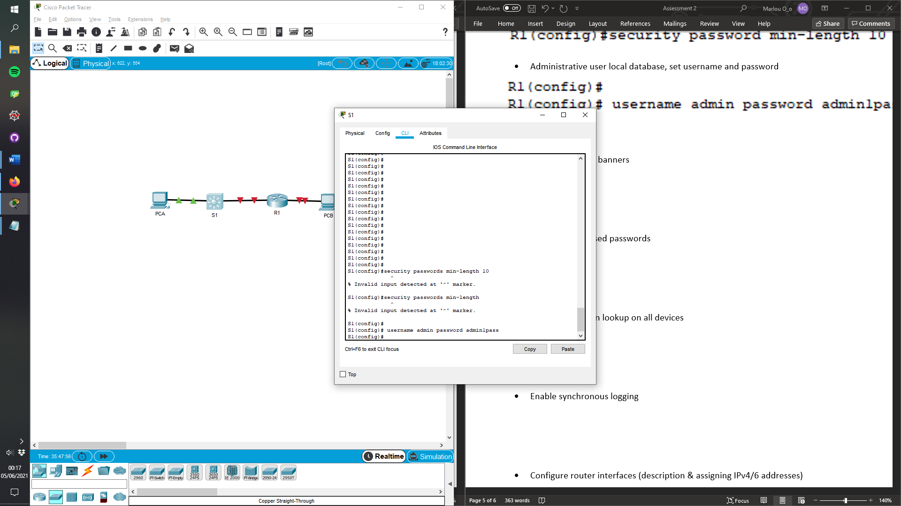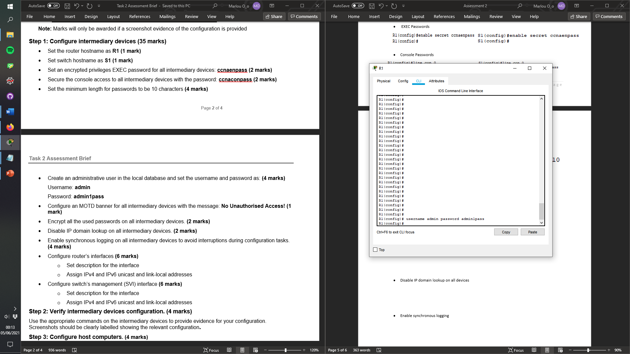Administrative user local database, set username and password
* 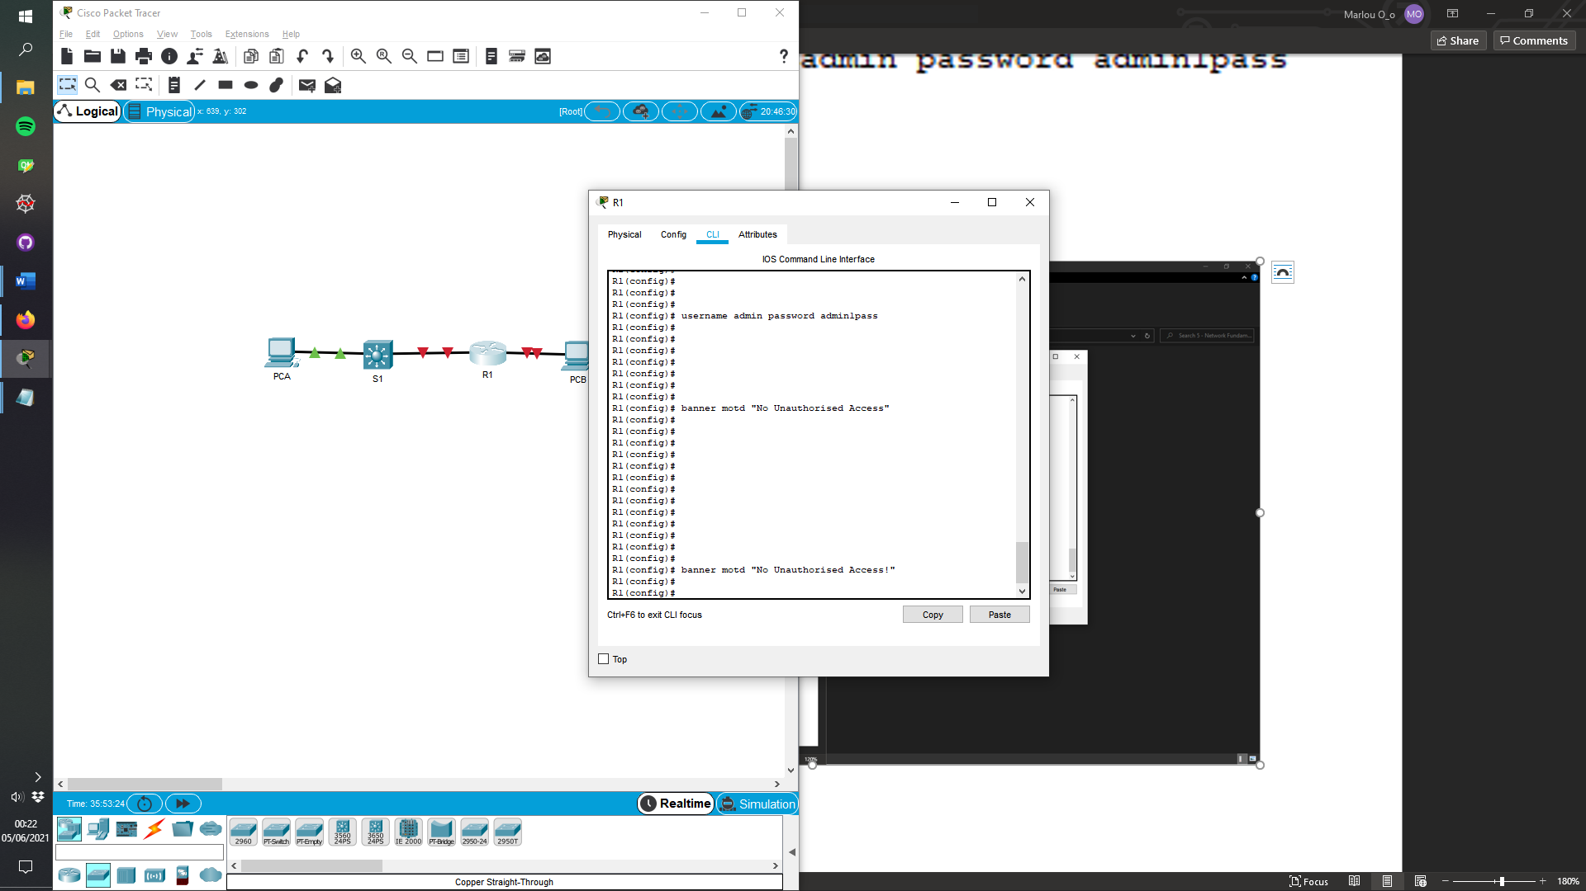Configure MOTD banners

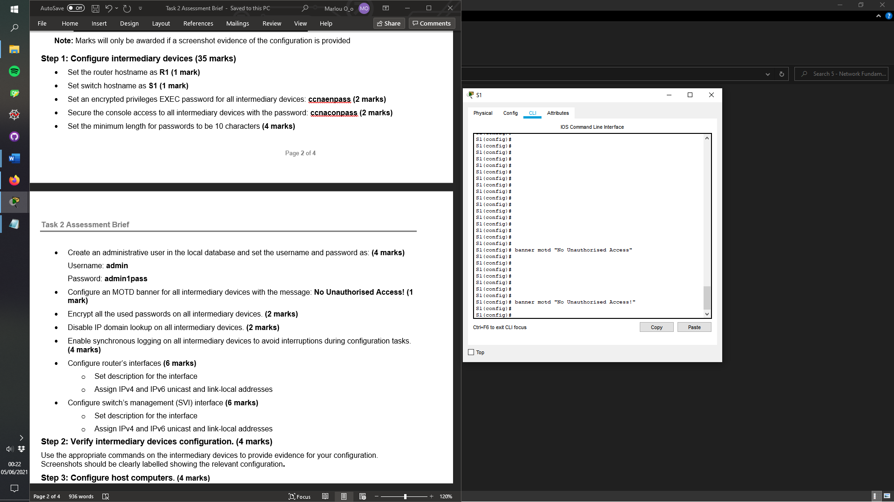

* 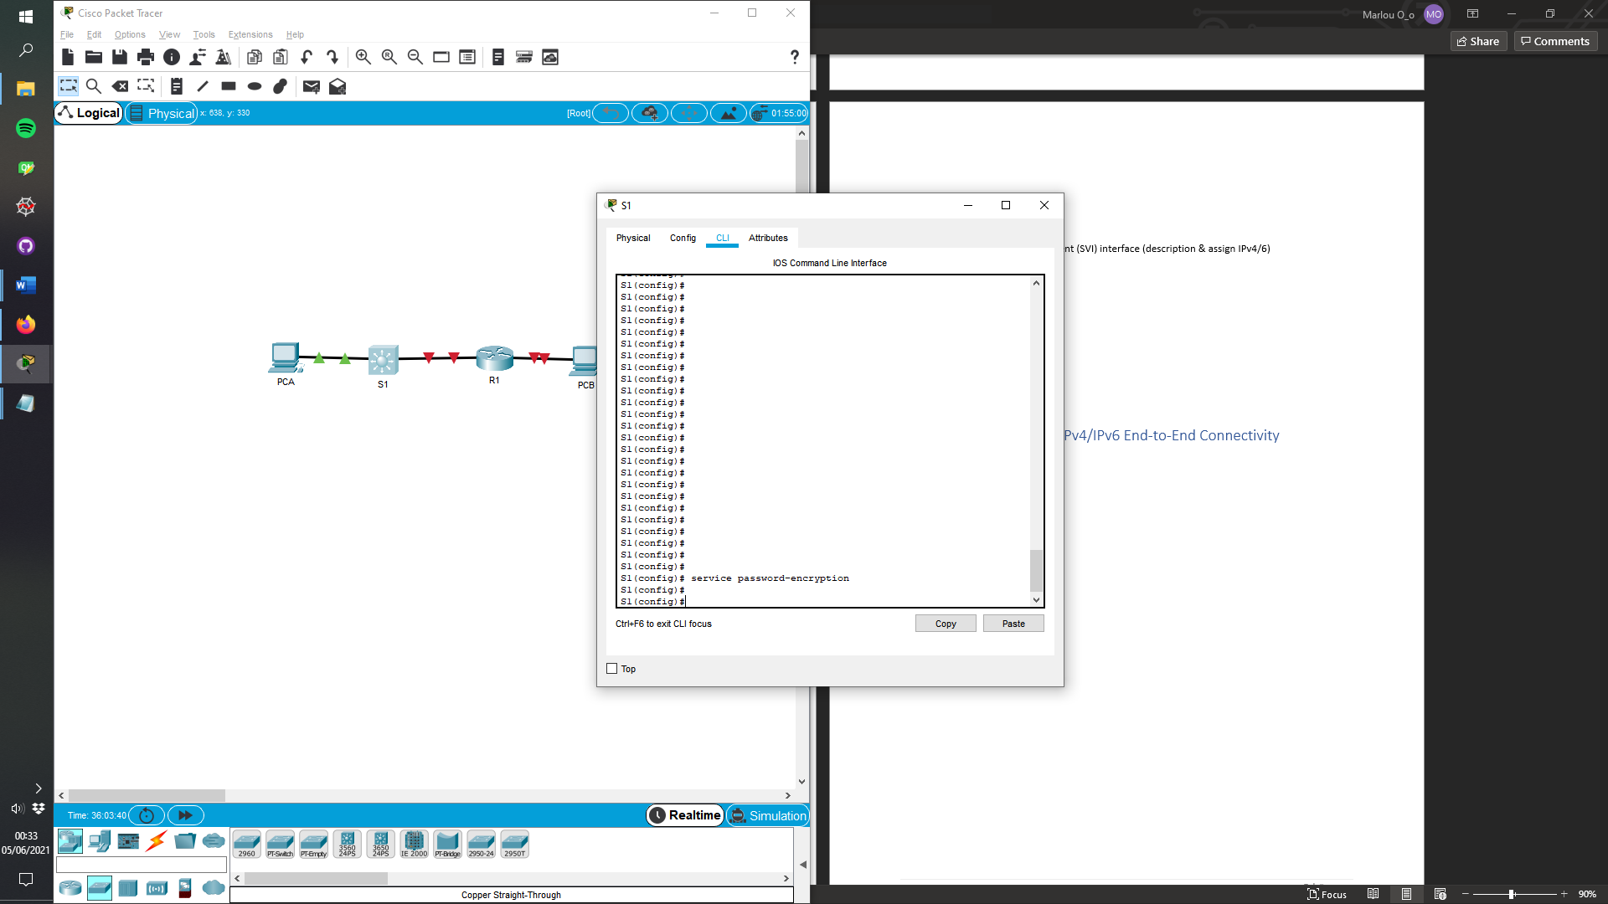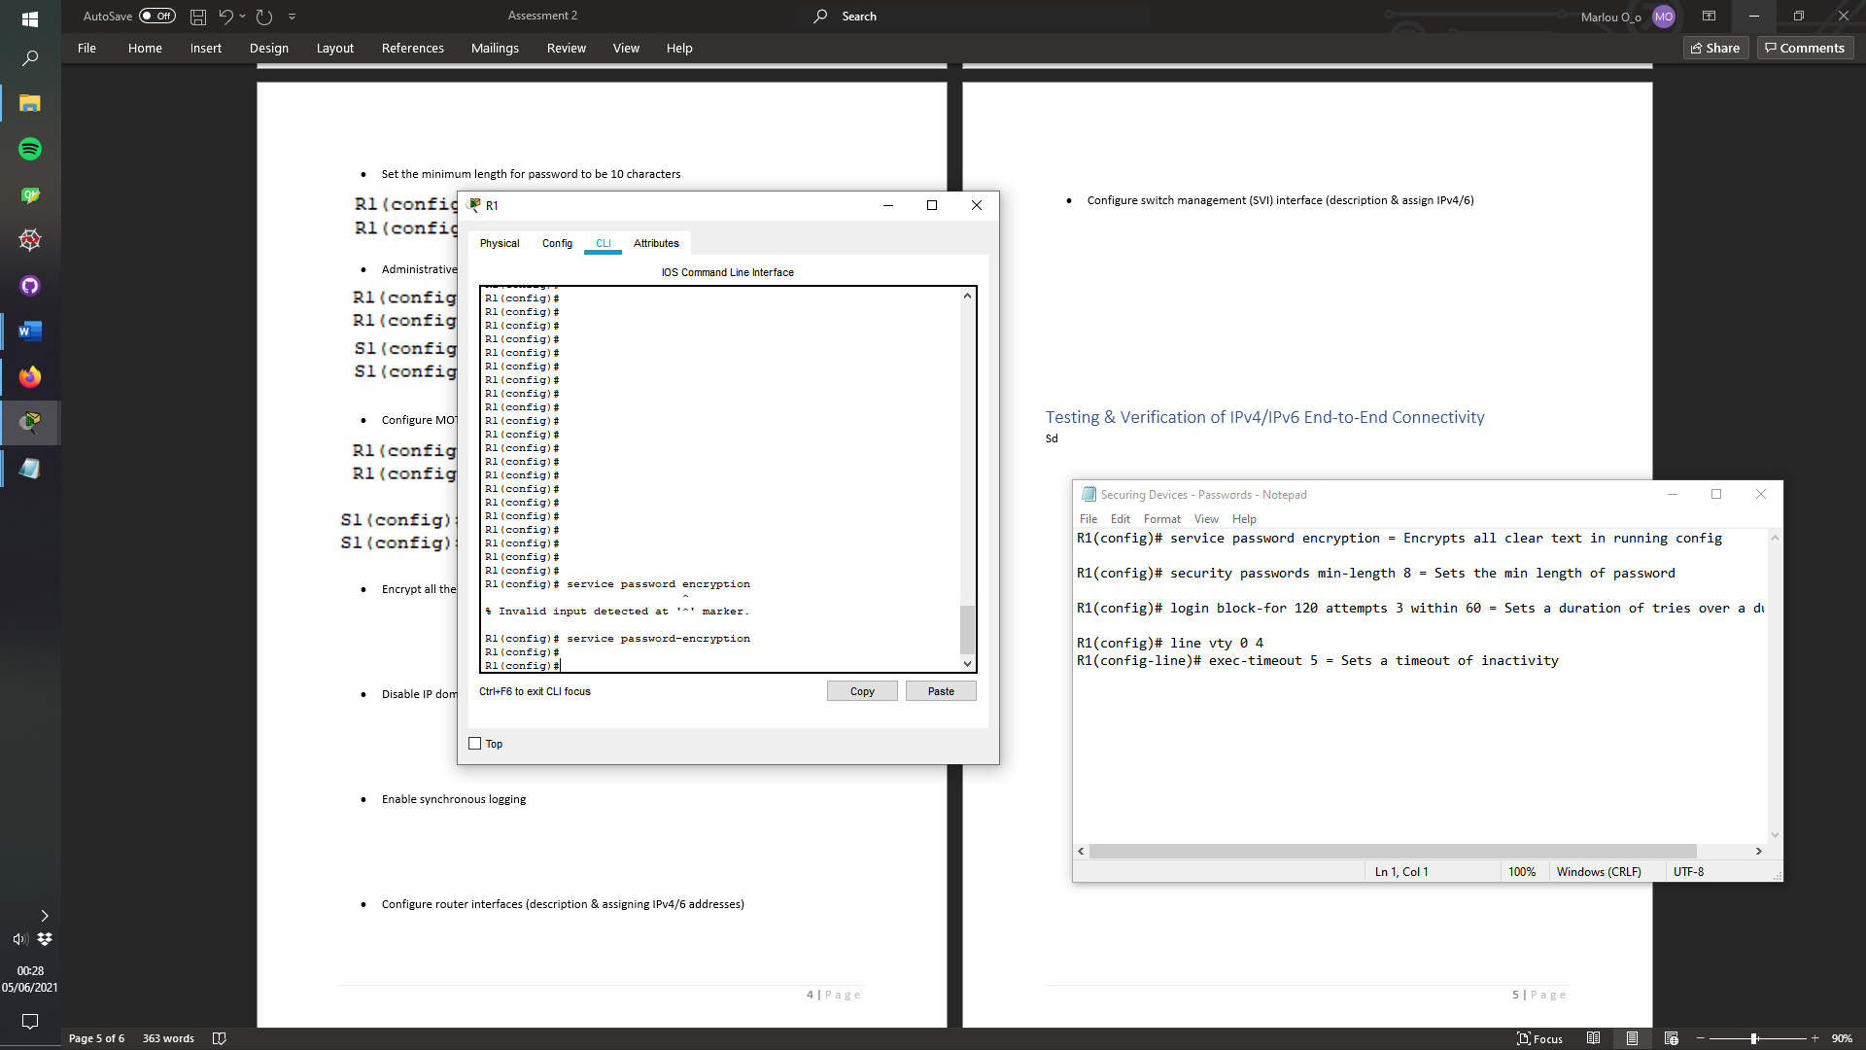Encrypt all the used passwords
* Disable IP domain lookup on all devices

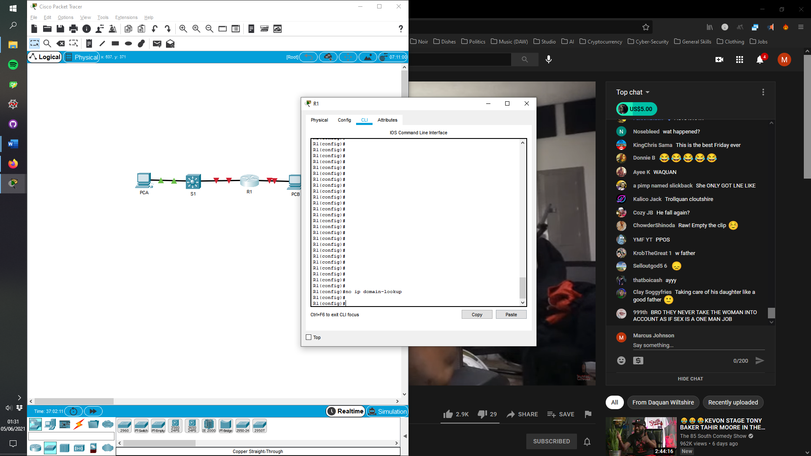

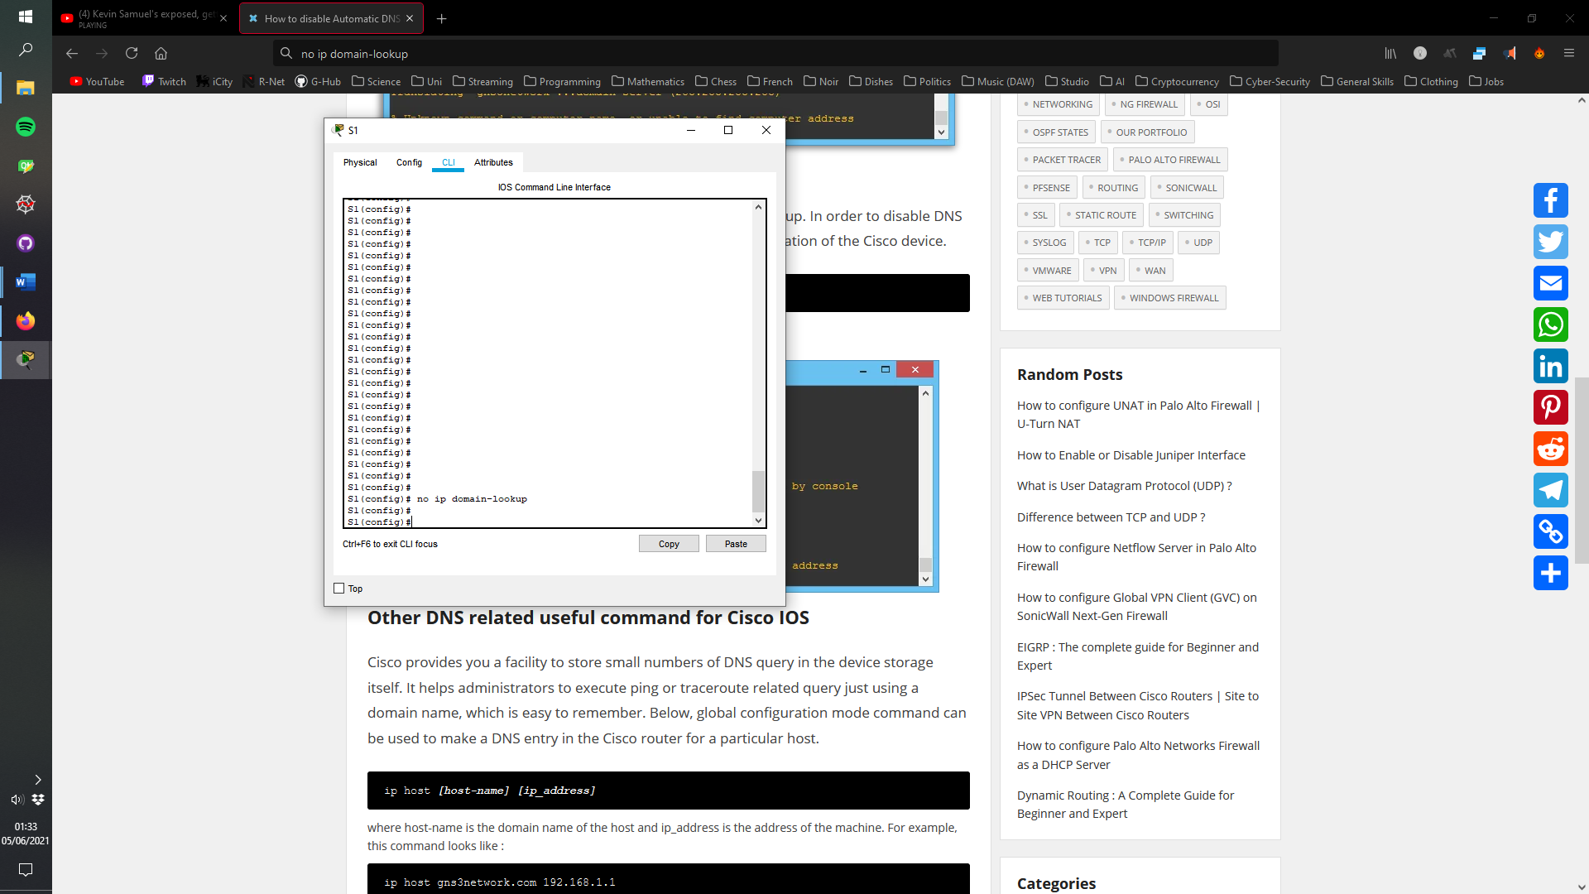

* Enable synchronous logging

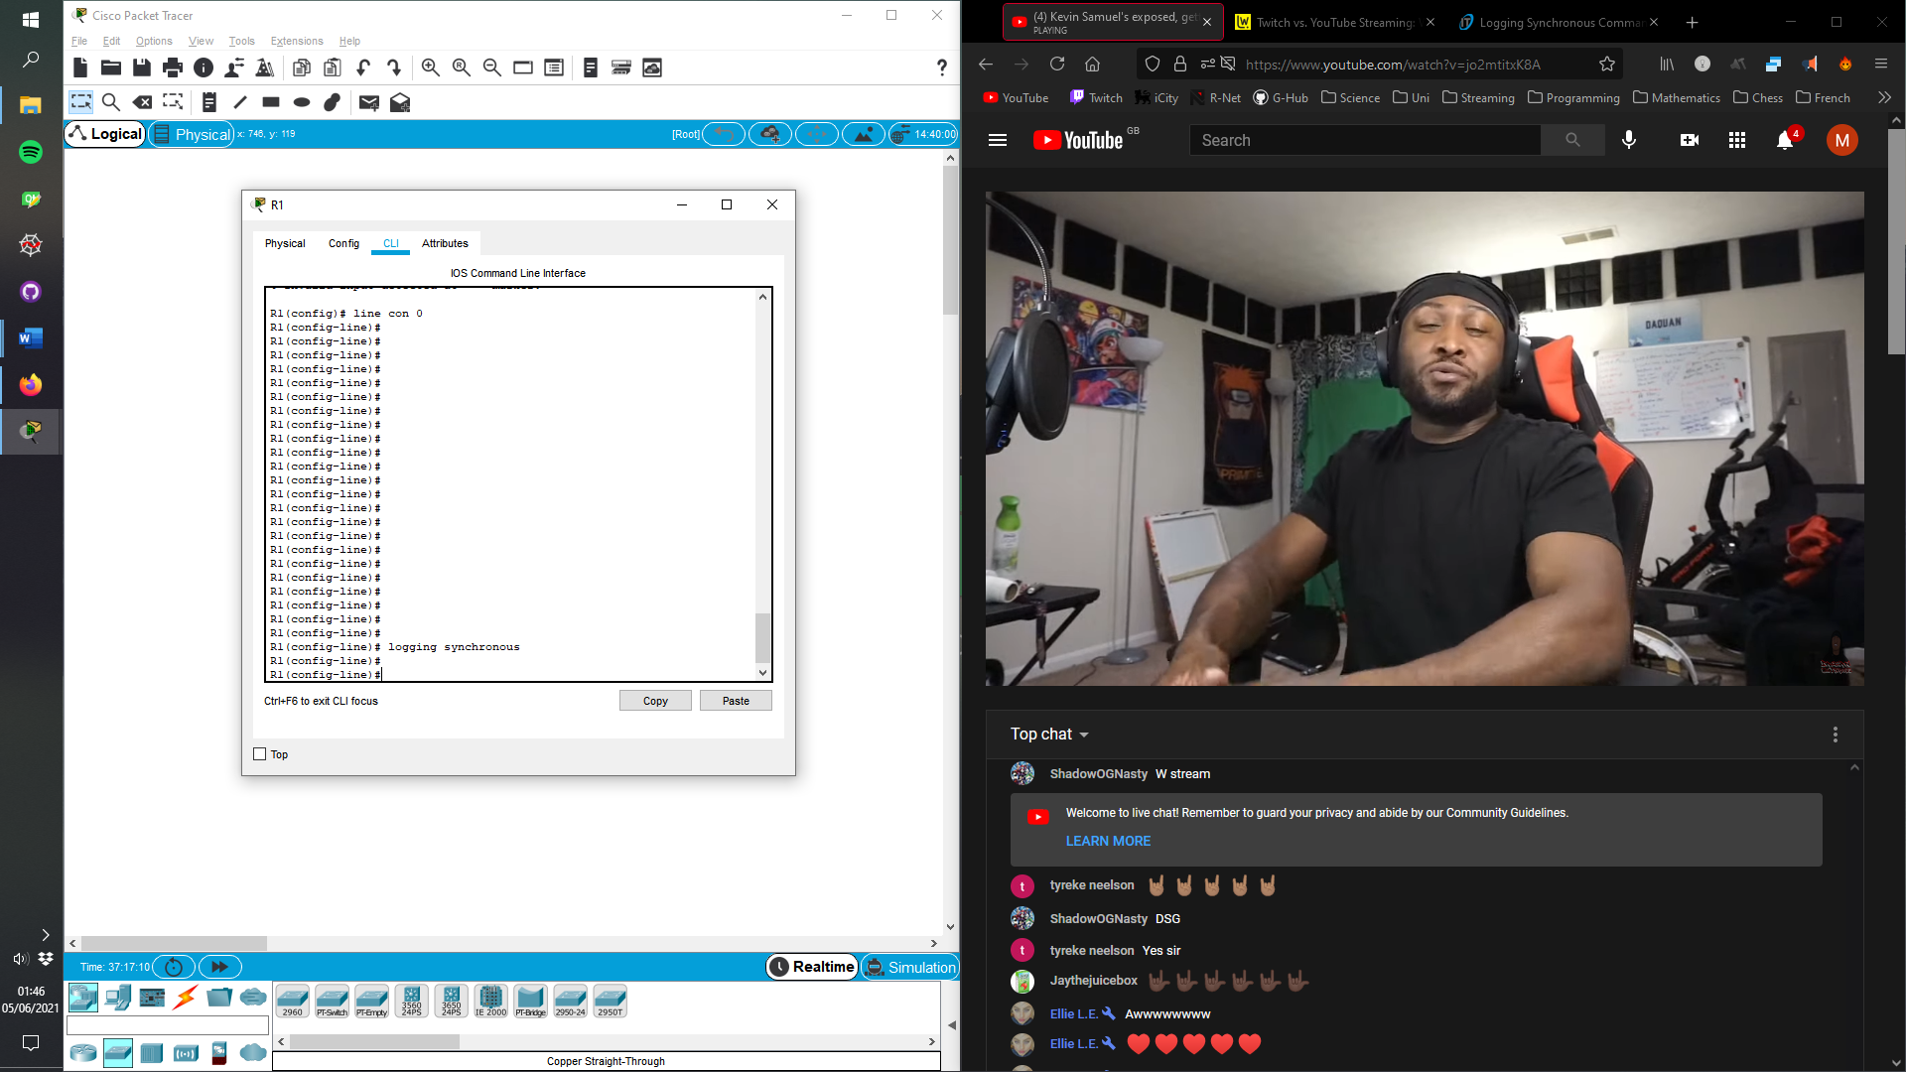

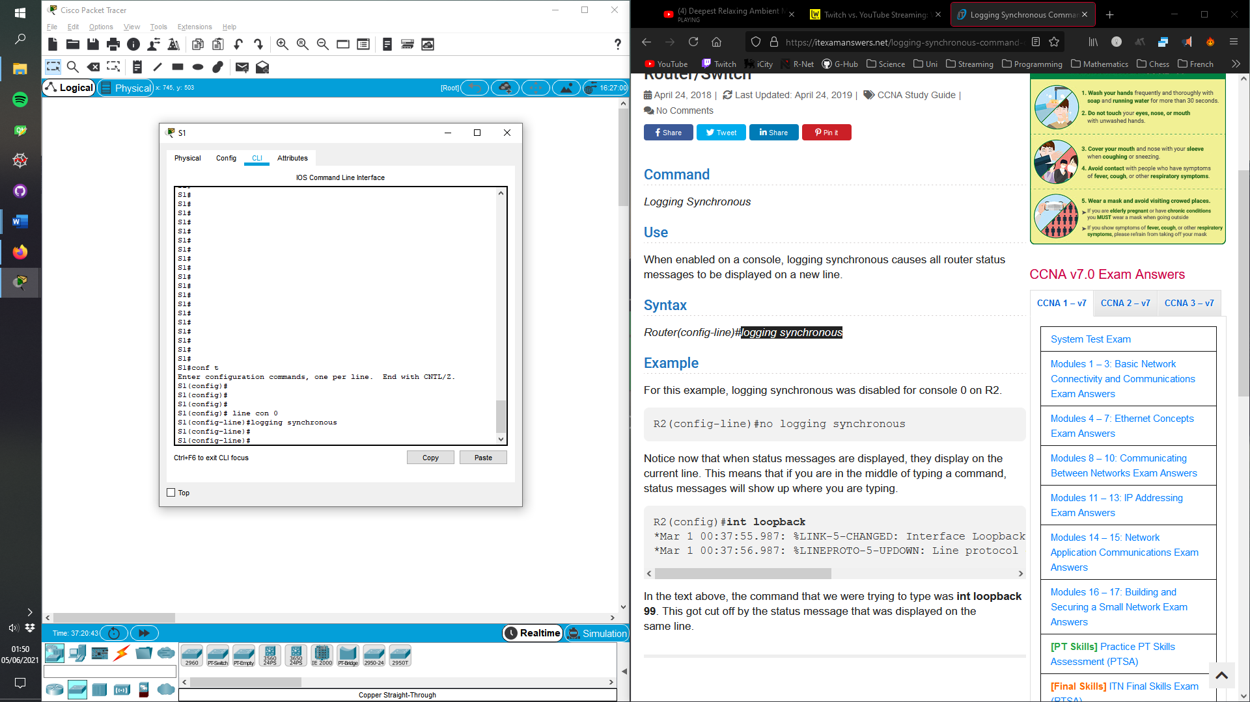

* 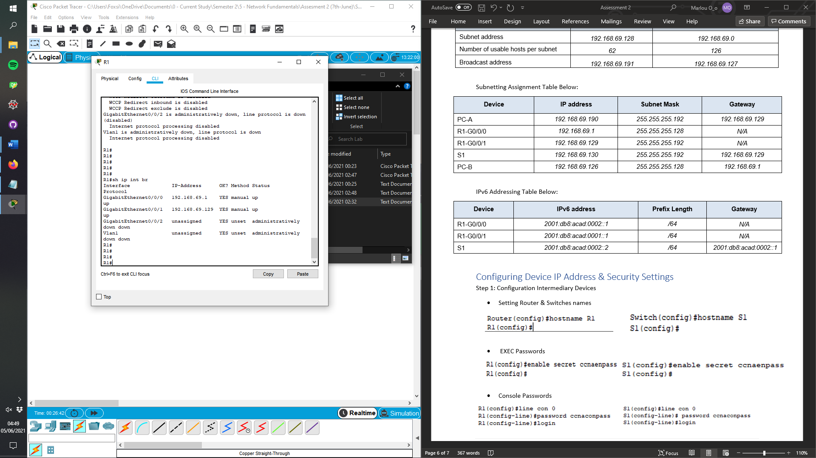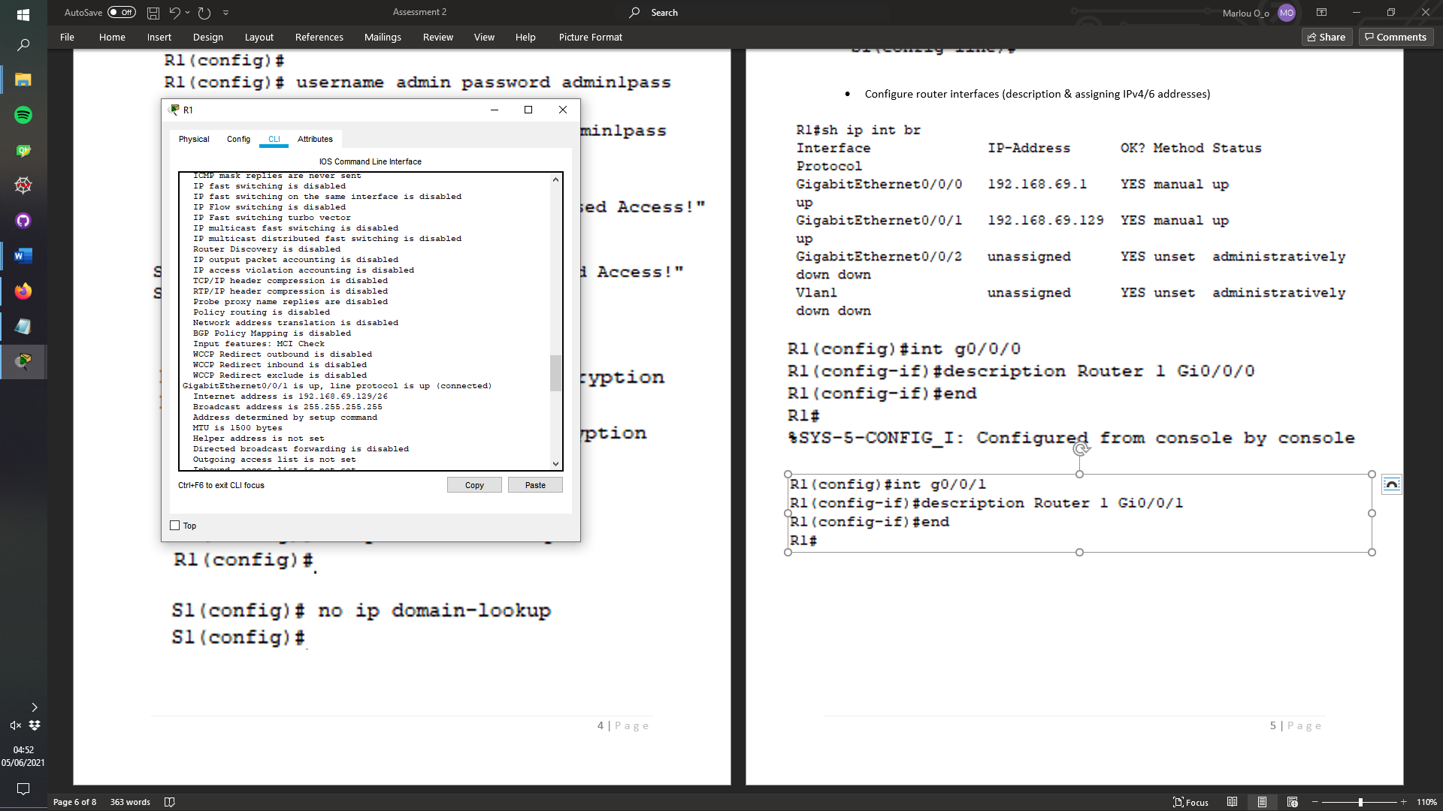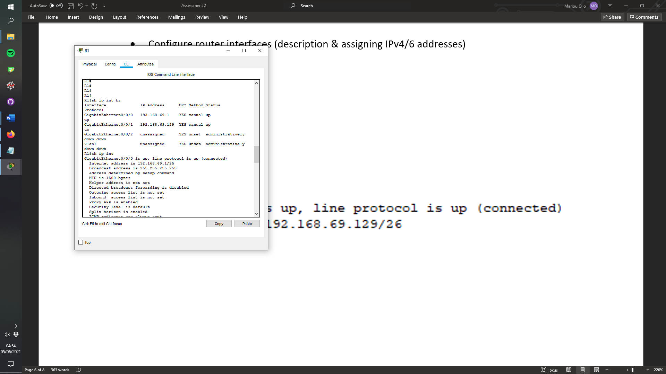Configure router interfaces (description & assigning IPv4/6 addresses)

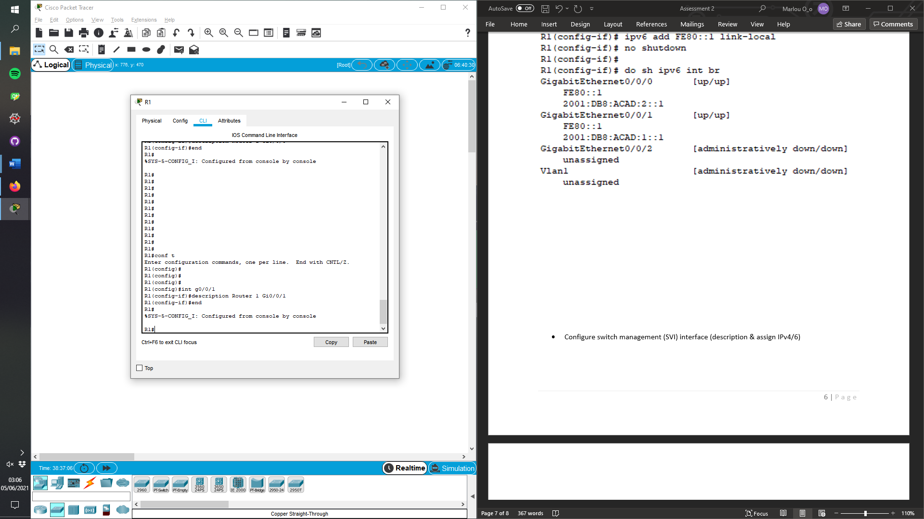

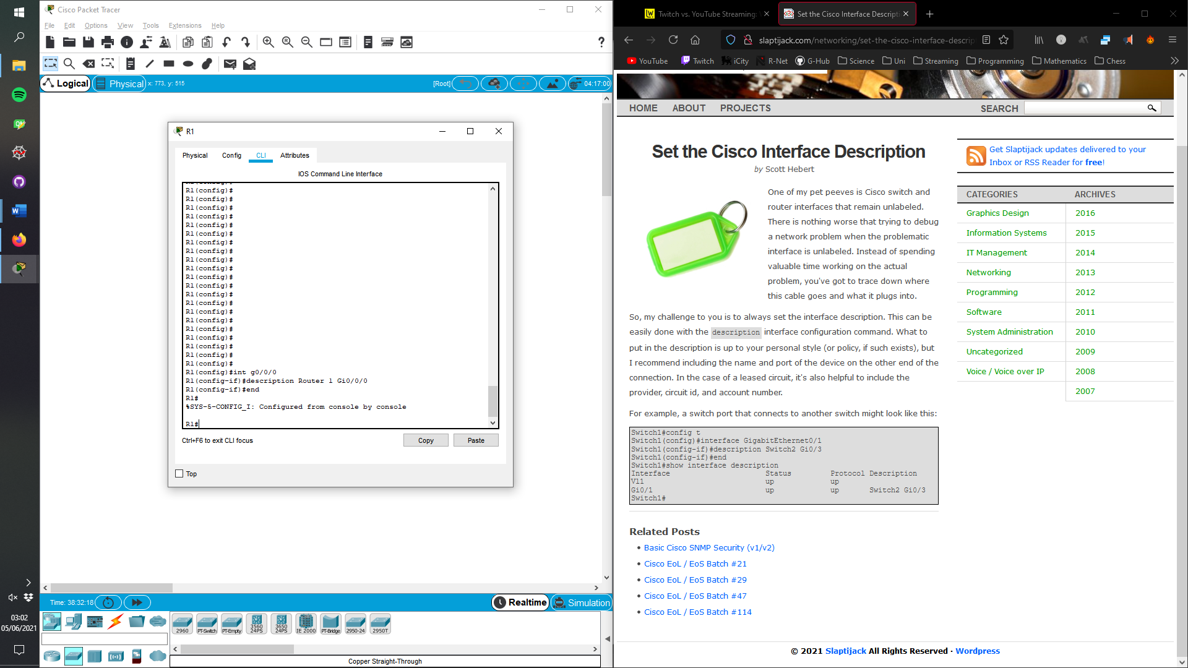

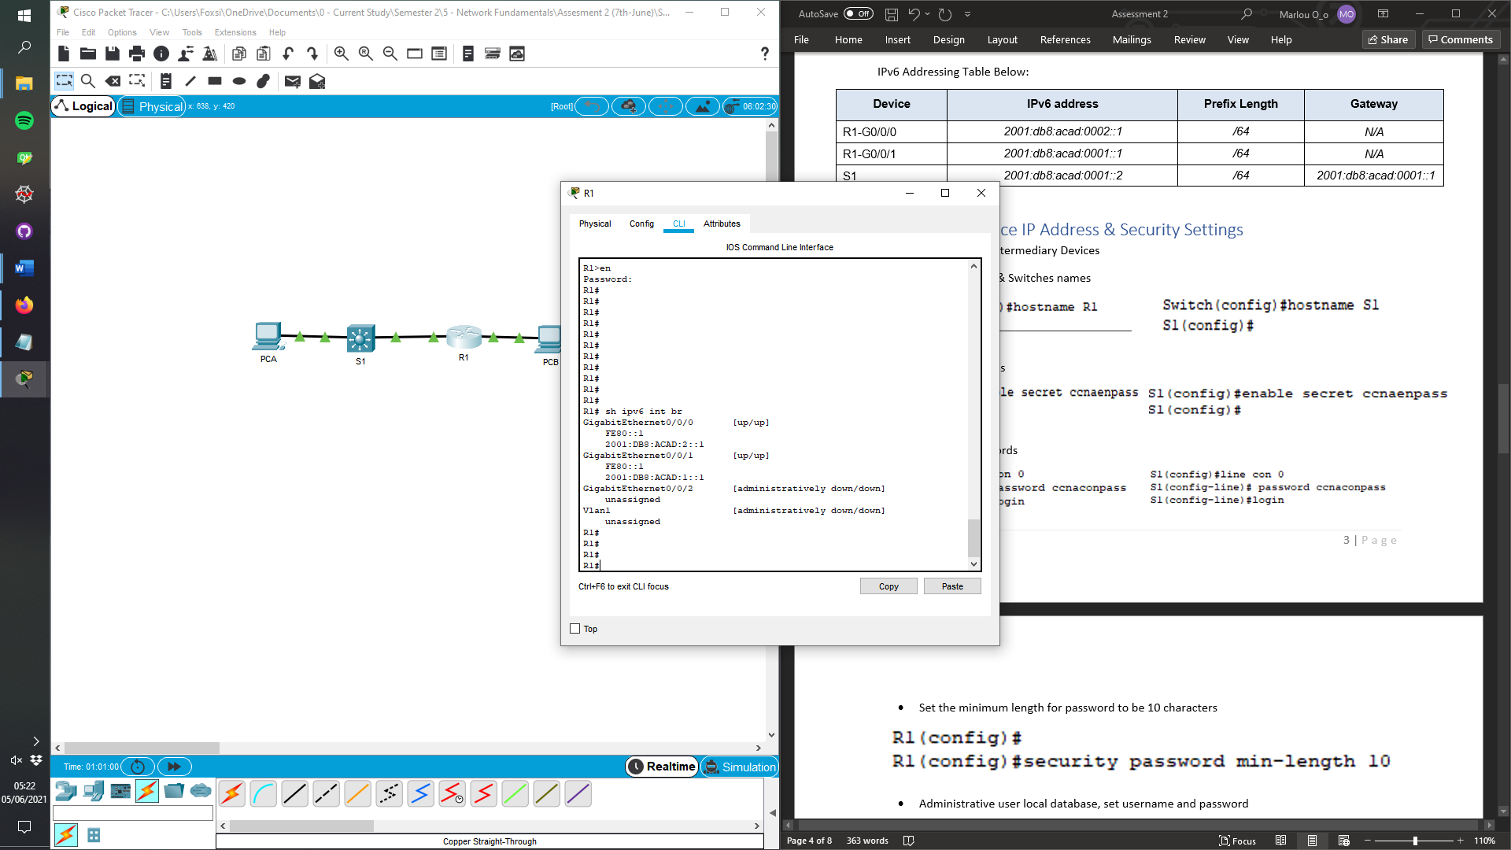

* 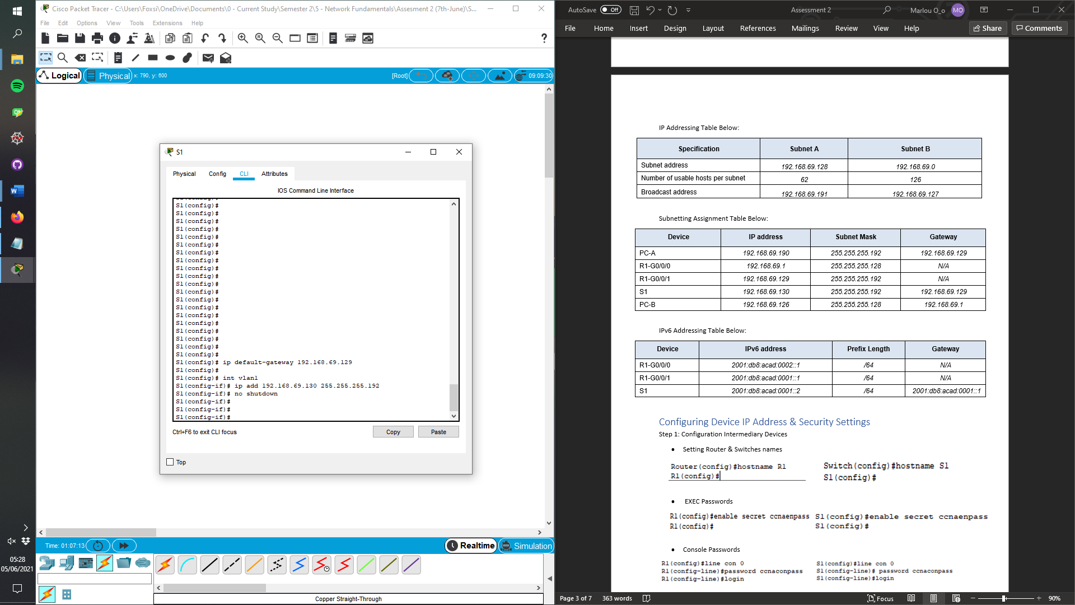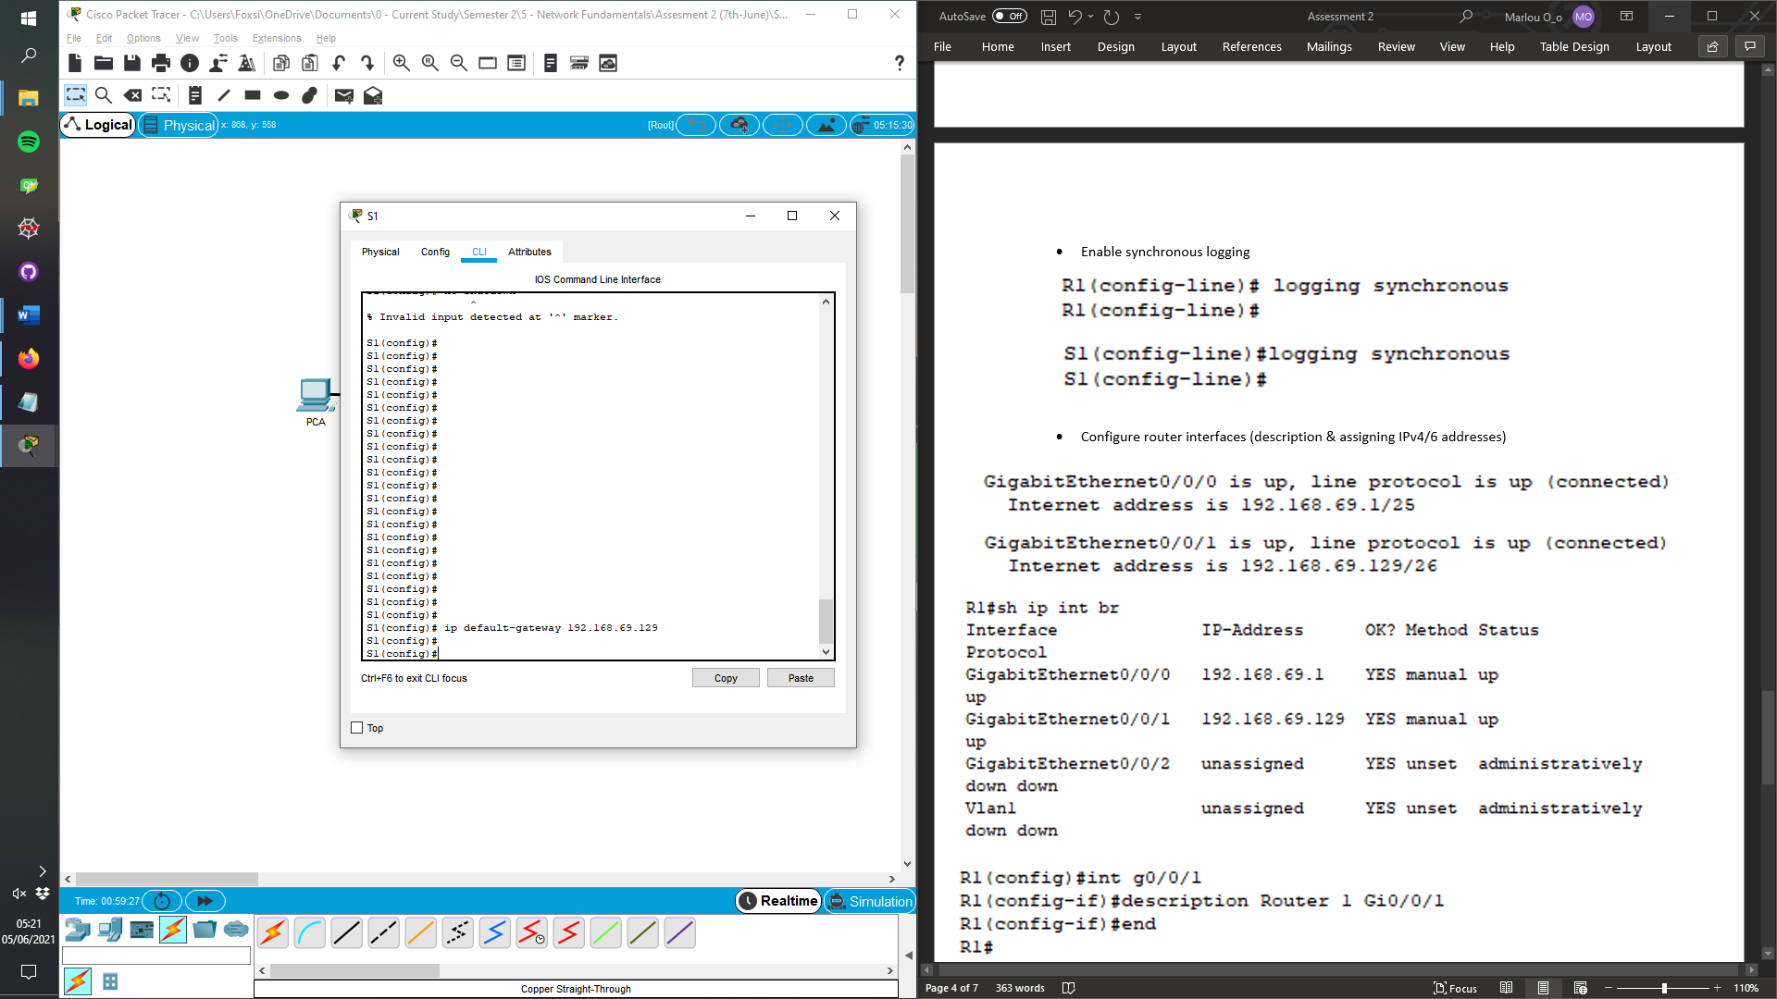Configure switch management (SVI) interface (description & assign IPv4/6)

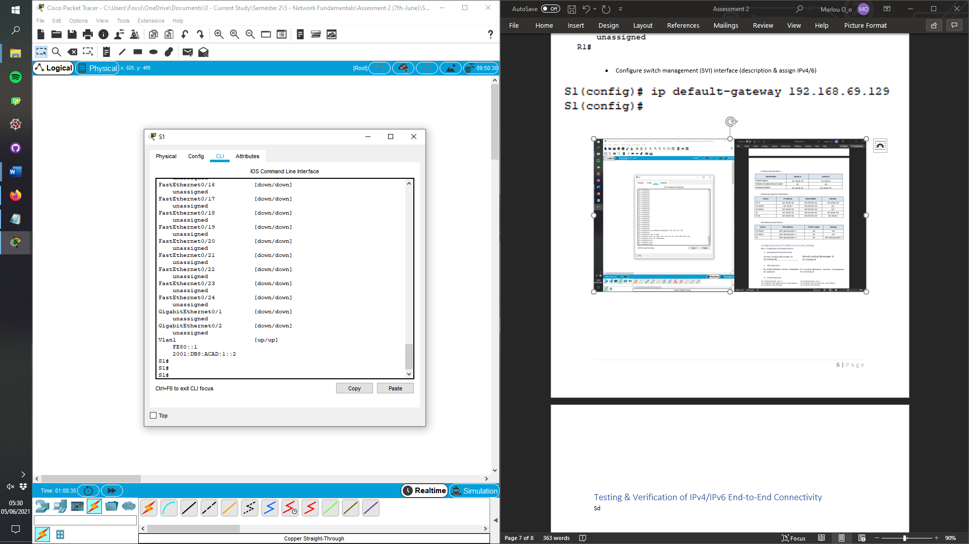

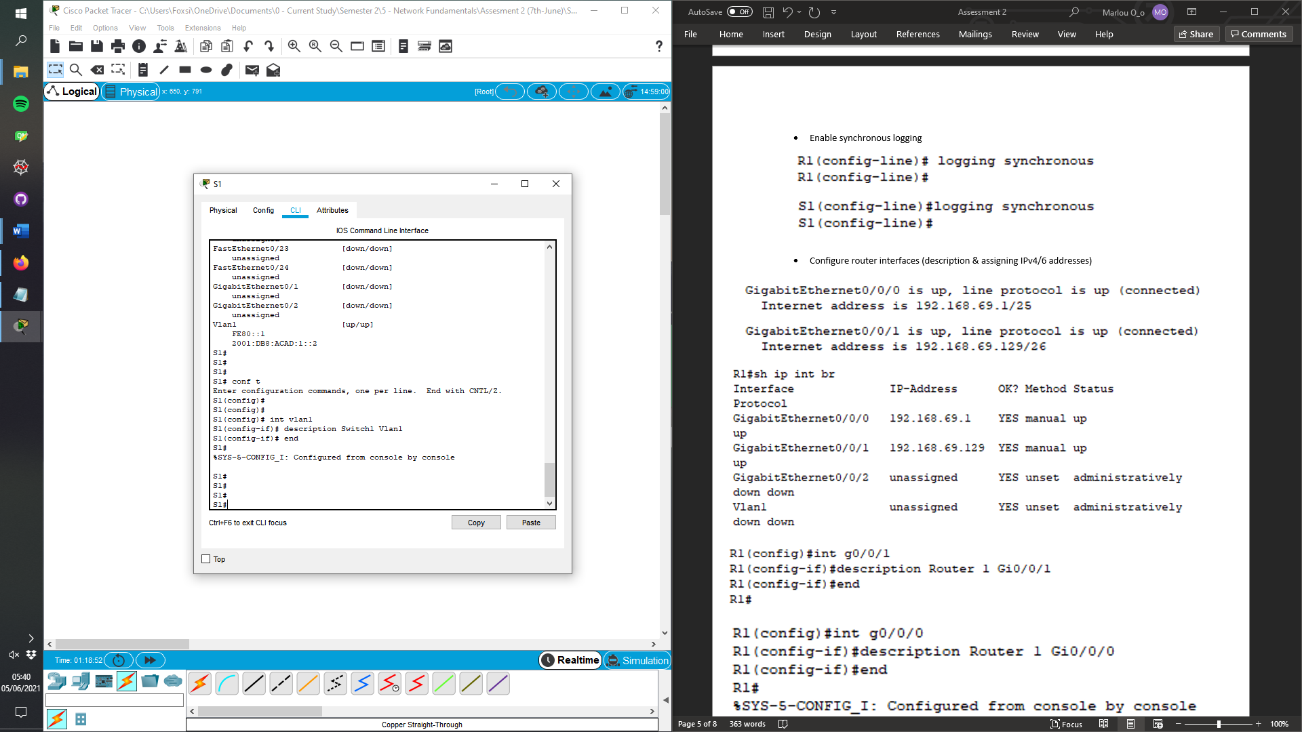

Step 2: Verifying intermediary devices configuration

* Switch Config

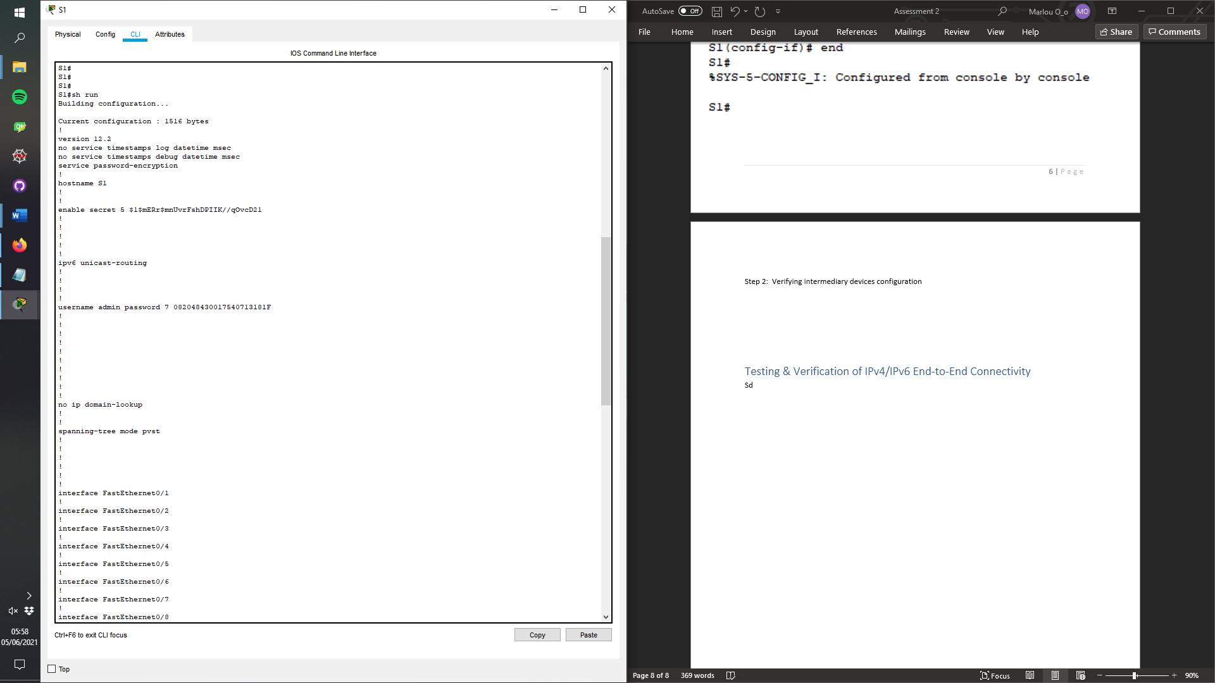

All clear text password are encrypted

Hostname change to appropriate name

Secret password for EXEC mode

Unicast routing enabled

Username & password set

No IP domain-lookup

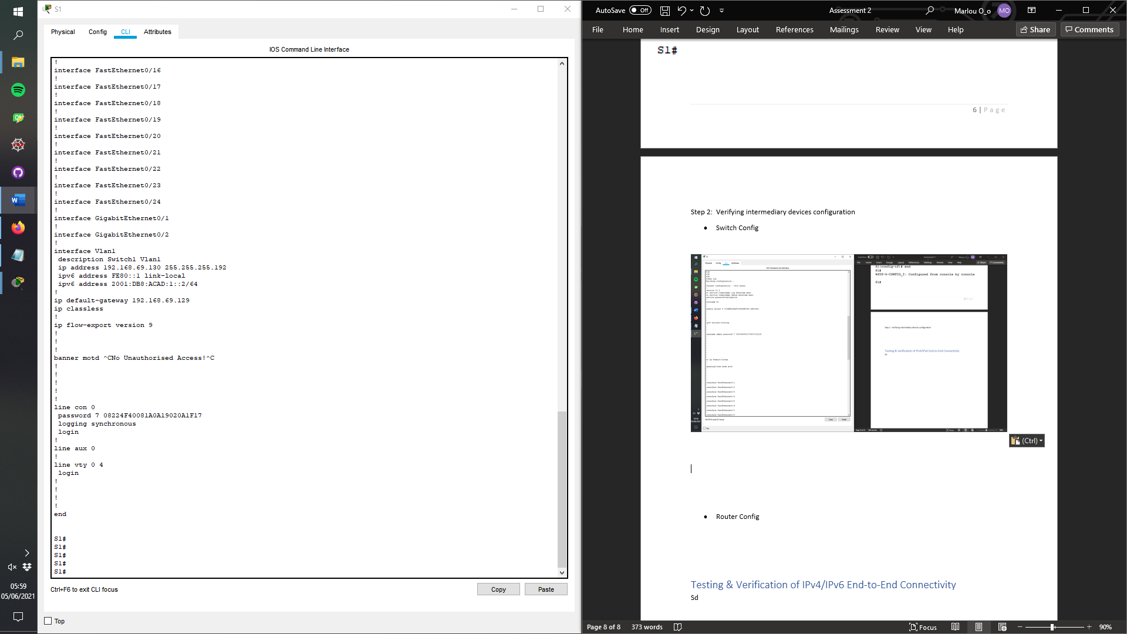

IP configurations for VLAN1 (IPv4/6)

Default gateway setup

Banner MOTD set to appropriate message.

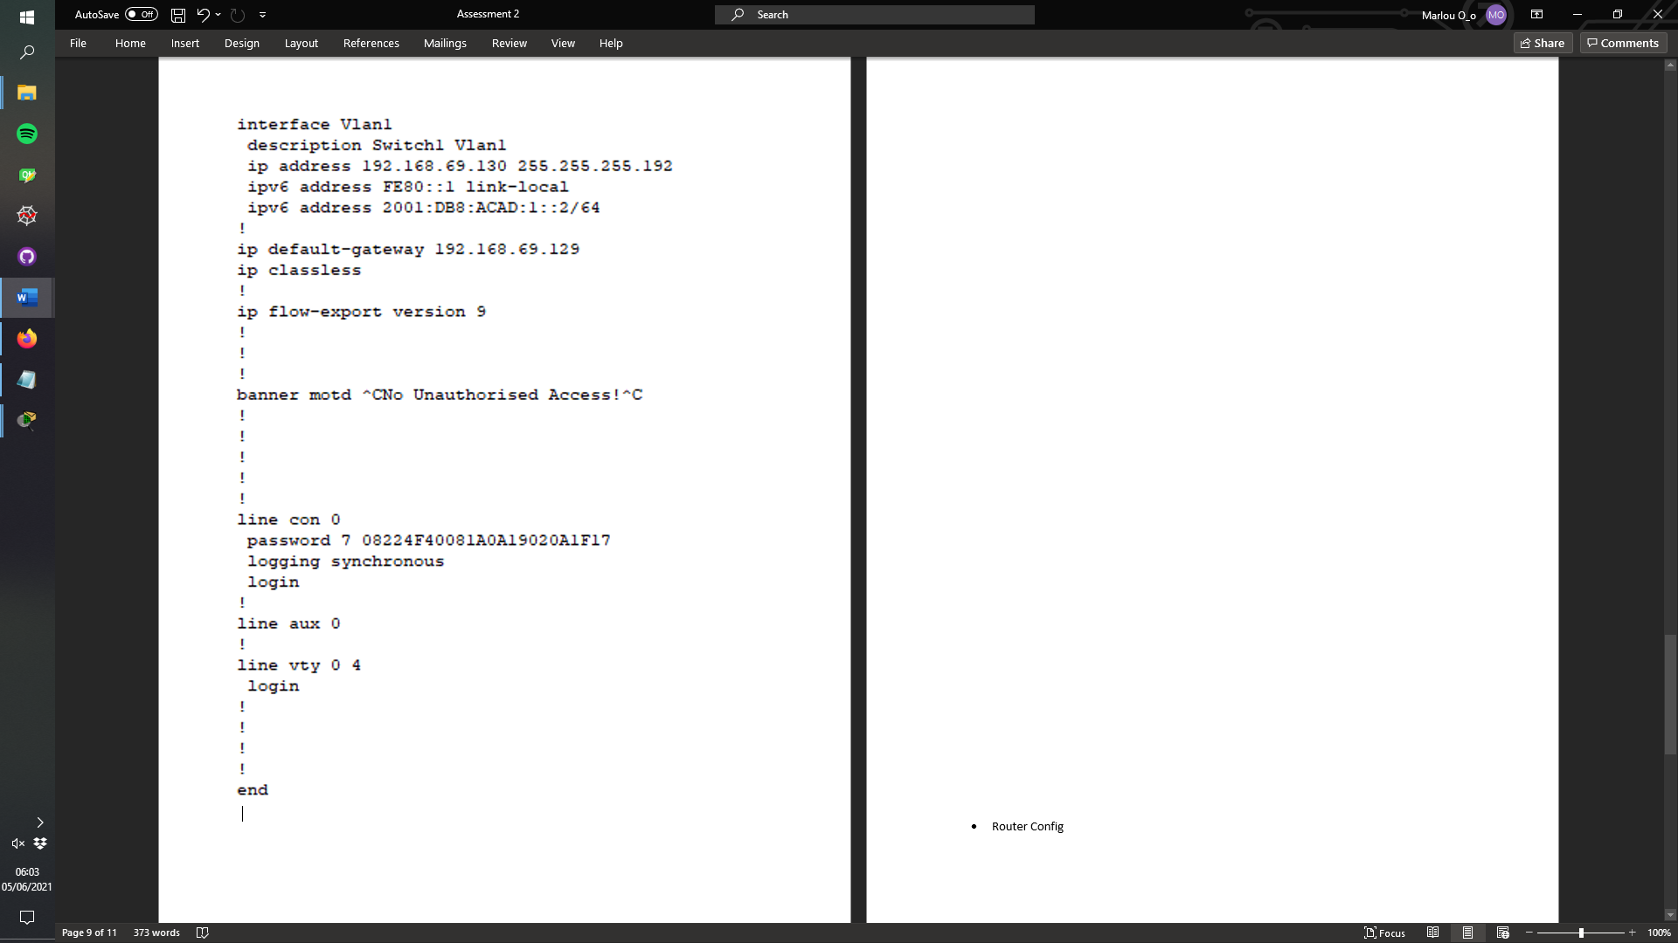

Console line 0, with a password set & synchronous logging

* Router Config

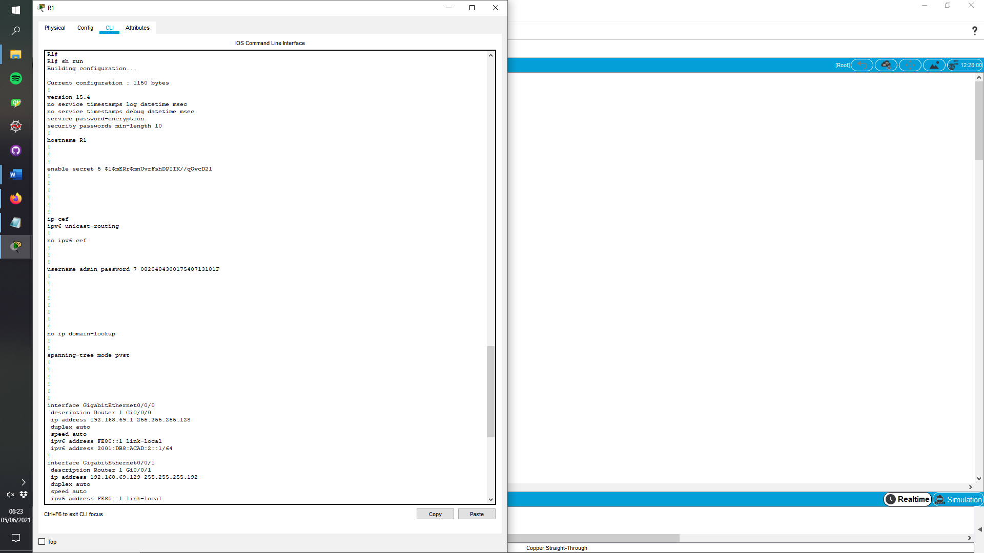

Password min-length set, and hostname changed. All clear text passwords encrypted

EXEC password set

Unicast routing enable

Username & password set & no IP domain-lookup

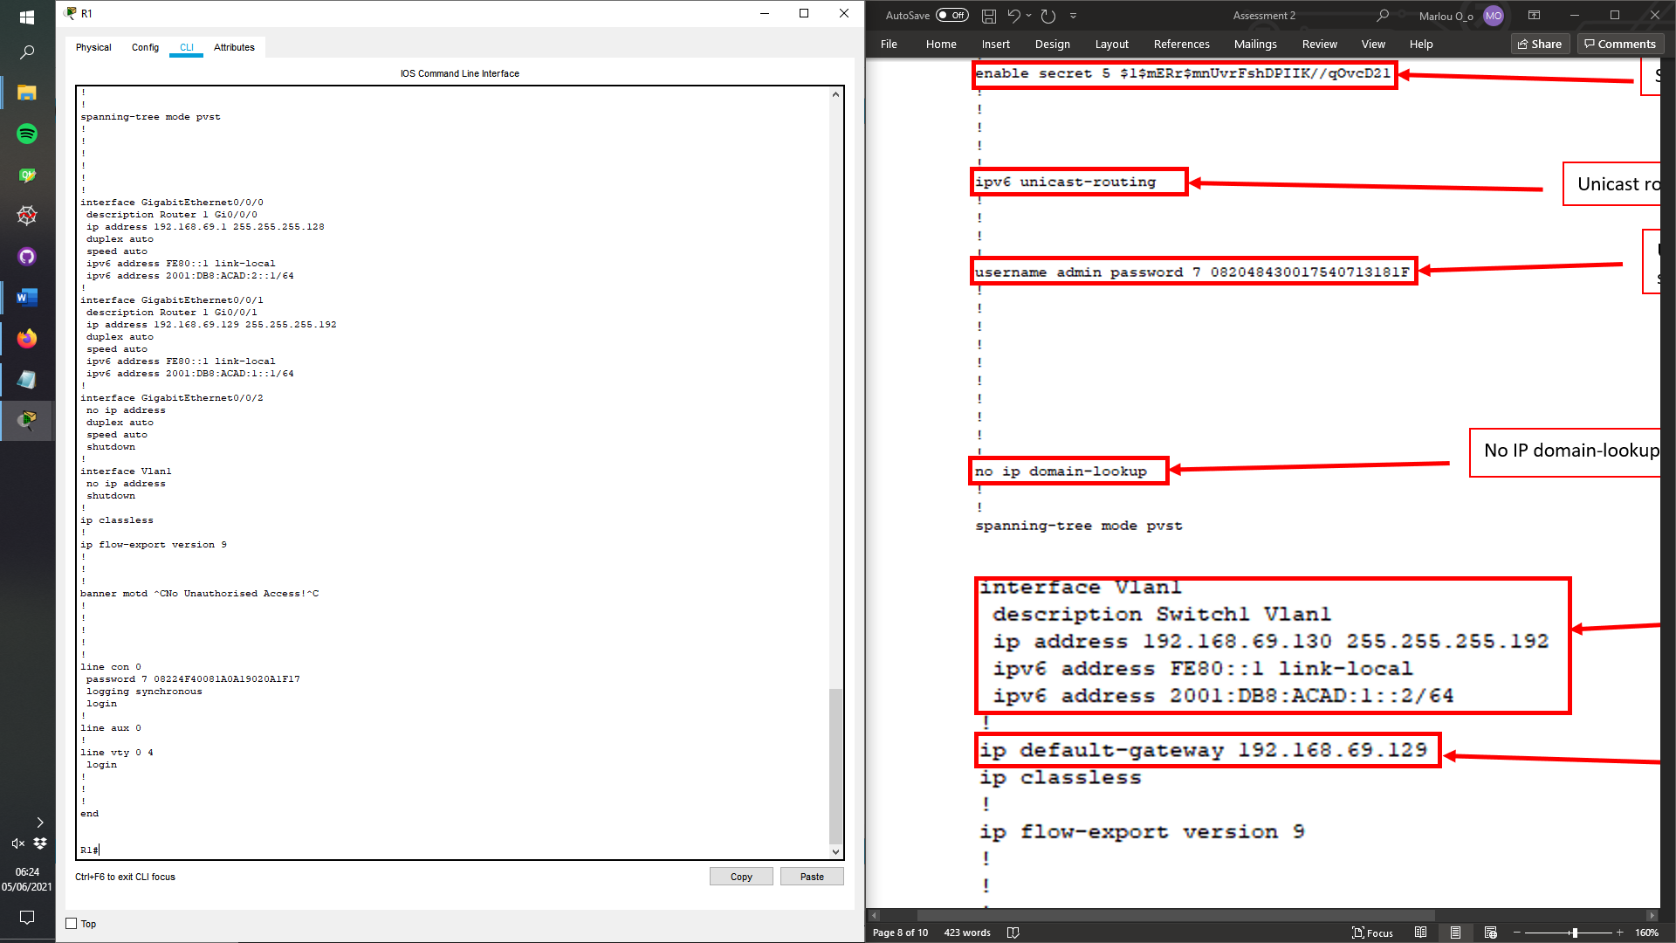

Console password set and password set. In addition to logging being synchronous.

Banner MOTD with appropriate message.

Interface Gi0/0/1 has description, appropriate IPv4/6 address are setting.

Interface Gi0/0/0 has description, appropriate IPv4/6 address are setting.

Step 3: Configure Host Computer

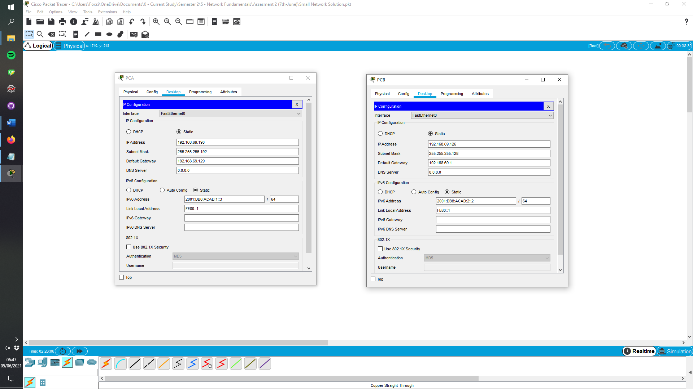

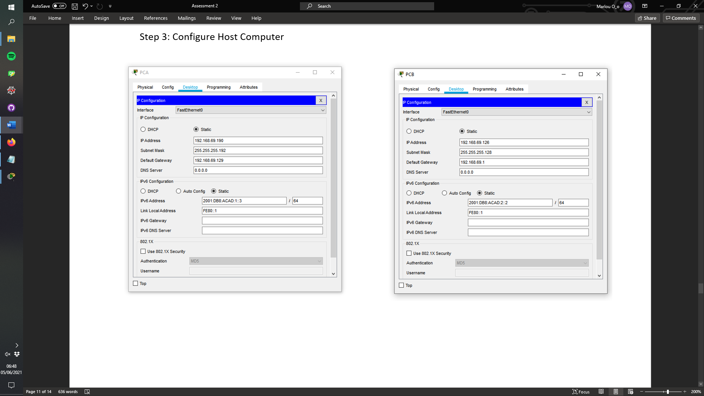

Step 4: Verify Host Computers

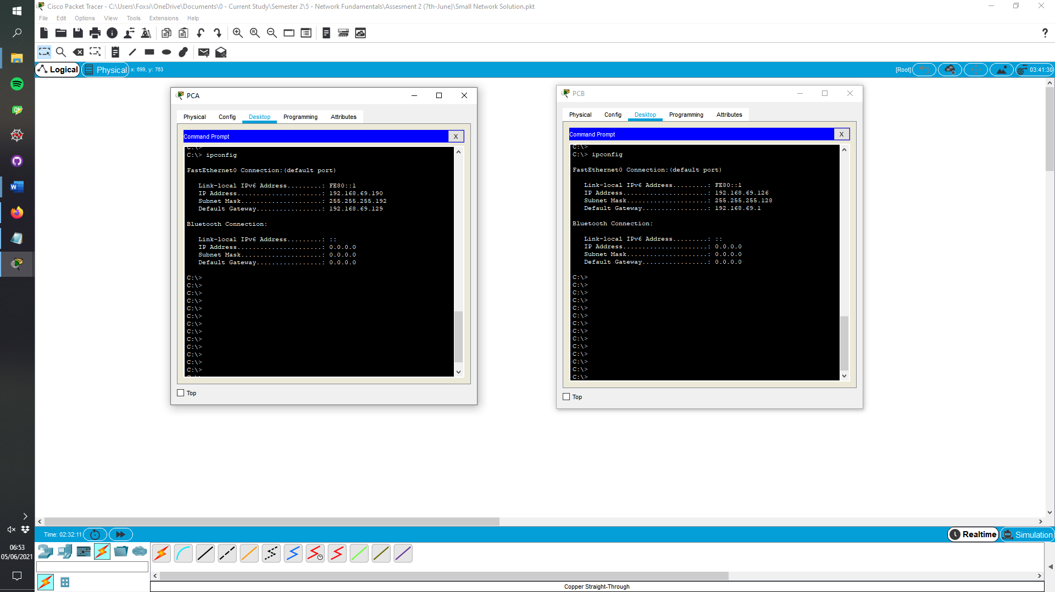

Ipconfig was used to verify the settings were assign to the host.



Ipconfig was used to verify the settings were assign to the host.

# Testing & Verification of IPv4/IPv6 End-to-End Connectivity

Step 1: ping tests

| From | To | IP Address | Ping Results |
| --- | --- | --- | --- |
| PC-A | R1 G0/0/0 | IPv4 | **Successful** |
| PC-A | R1 G0/0/0 | IPv6 | **Successful** |
| PC-A | R1 G0/0/1 | IPv4 | **Successful** |
| PC-A | R1 G0/0/1 | IPv6 | **Successful** |
| PC-A | S1 VLAN 1 | IPv4 | **Successful** |
| PC-A | S1 VLAN 1 | IPv6 | **Successful** |
| PC-A | PC-B | IPv4 | **Successful** |
| PC-A | PC-B | IPv6 | **Successful** |
| PC-B | R1 G0/0/0 | IPv4 |  |
| PC-B | R1 G0/0/0 | IPv6 |  |
| PC-B | R1 G0/0/1 | IPv4 |  |
| PC-B | R1 G0/0/1 | IPv6 |  |
| PC-B | S1 VLAN1 | IPv4 |  |
| PC-B | S1 VLAN1 | IPv6 |  |

PC-A Ping Test Screenshot

* 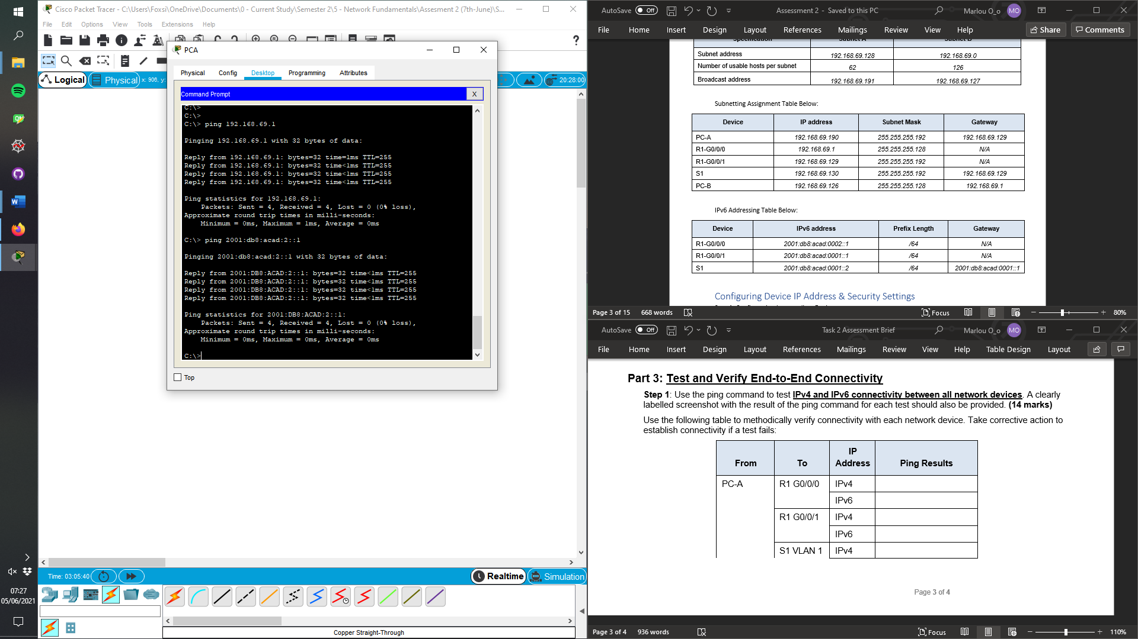G0/0/0
* G0/0/1

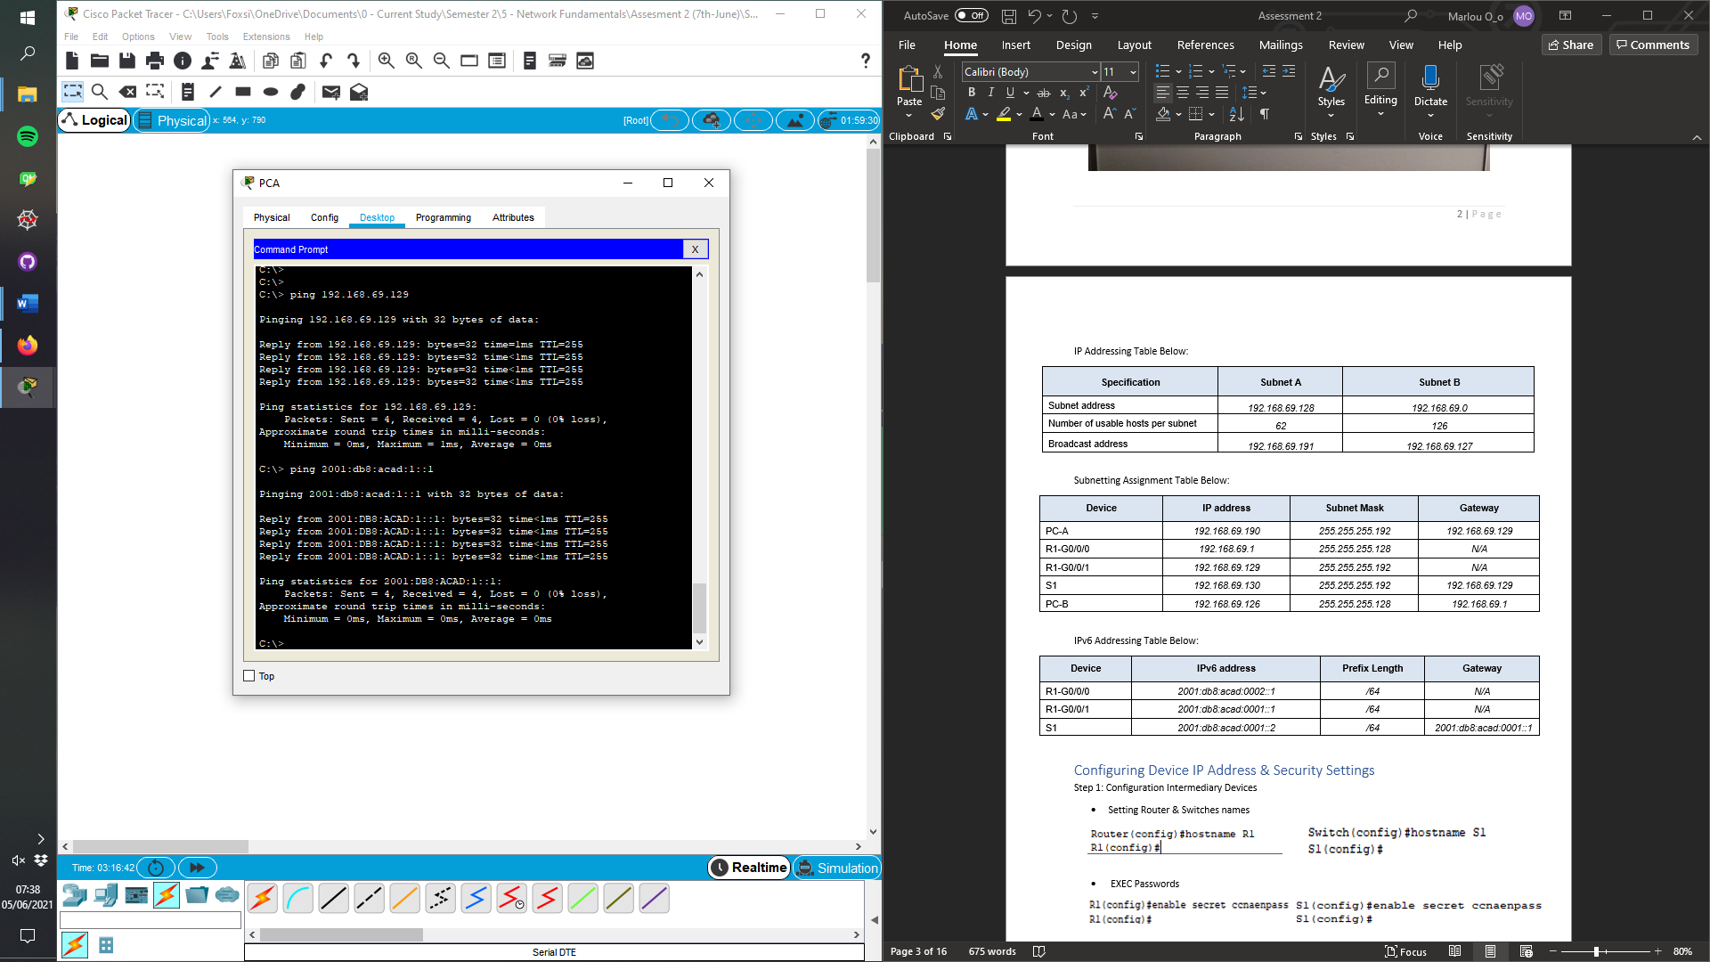

* S1 VLAN1

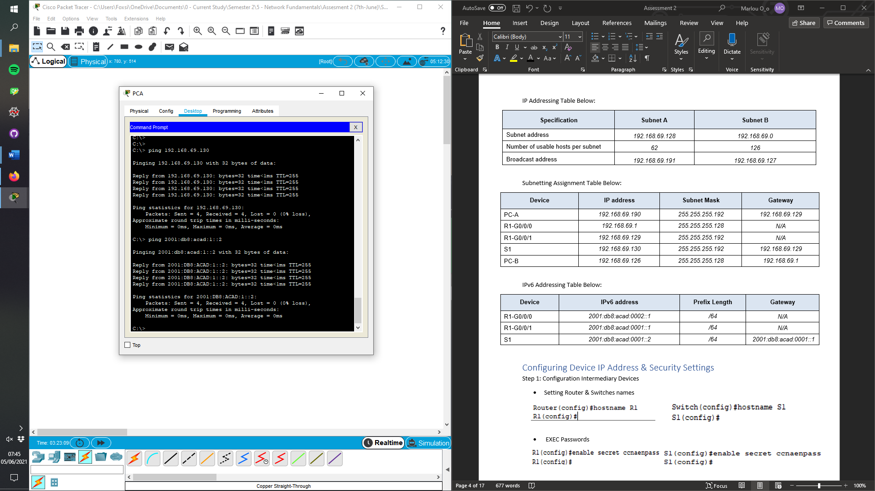

* 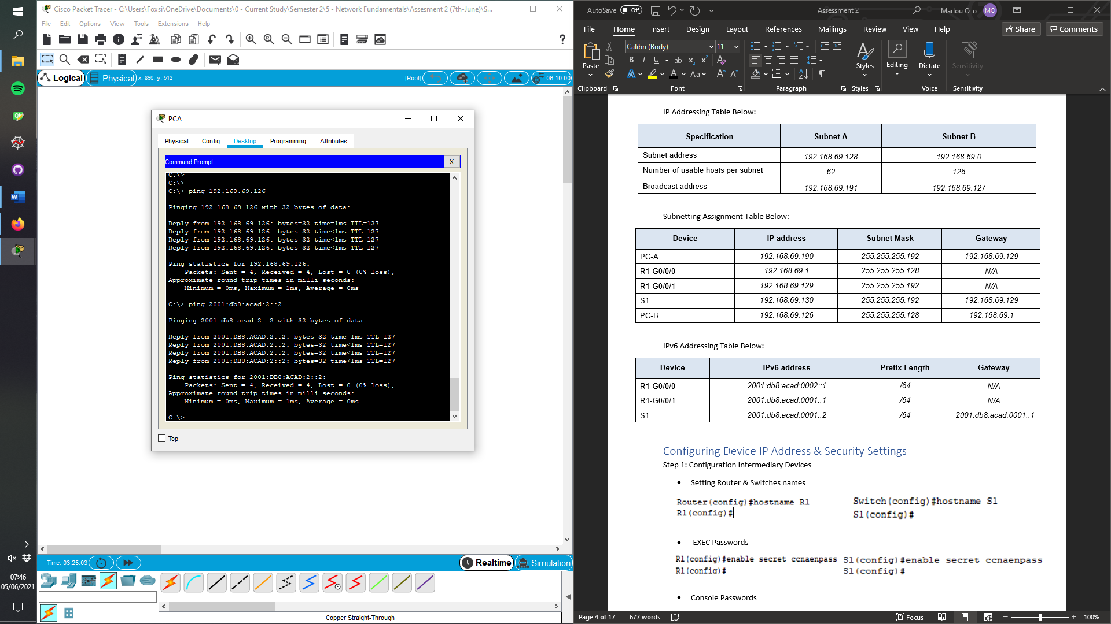PC-B

PC-B Ping Test Screenshot

* 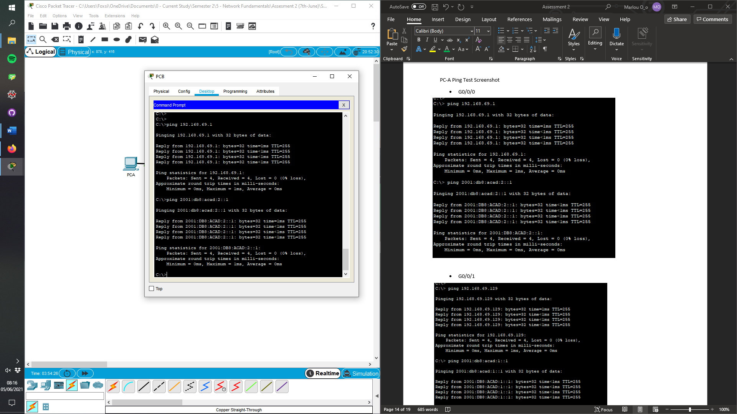G0/0/0
* 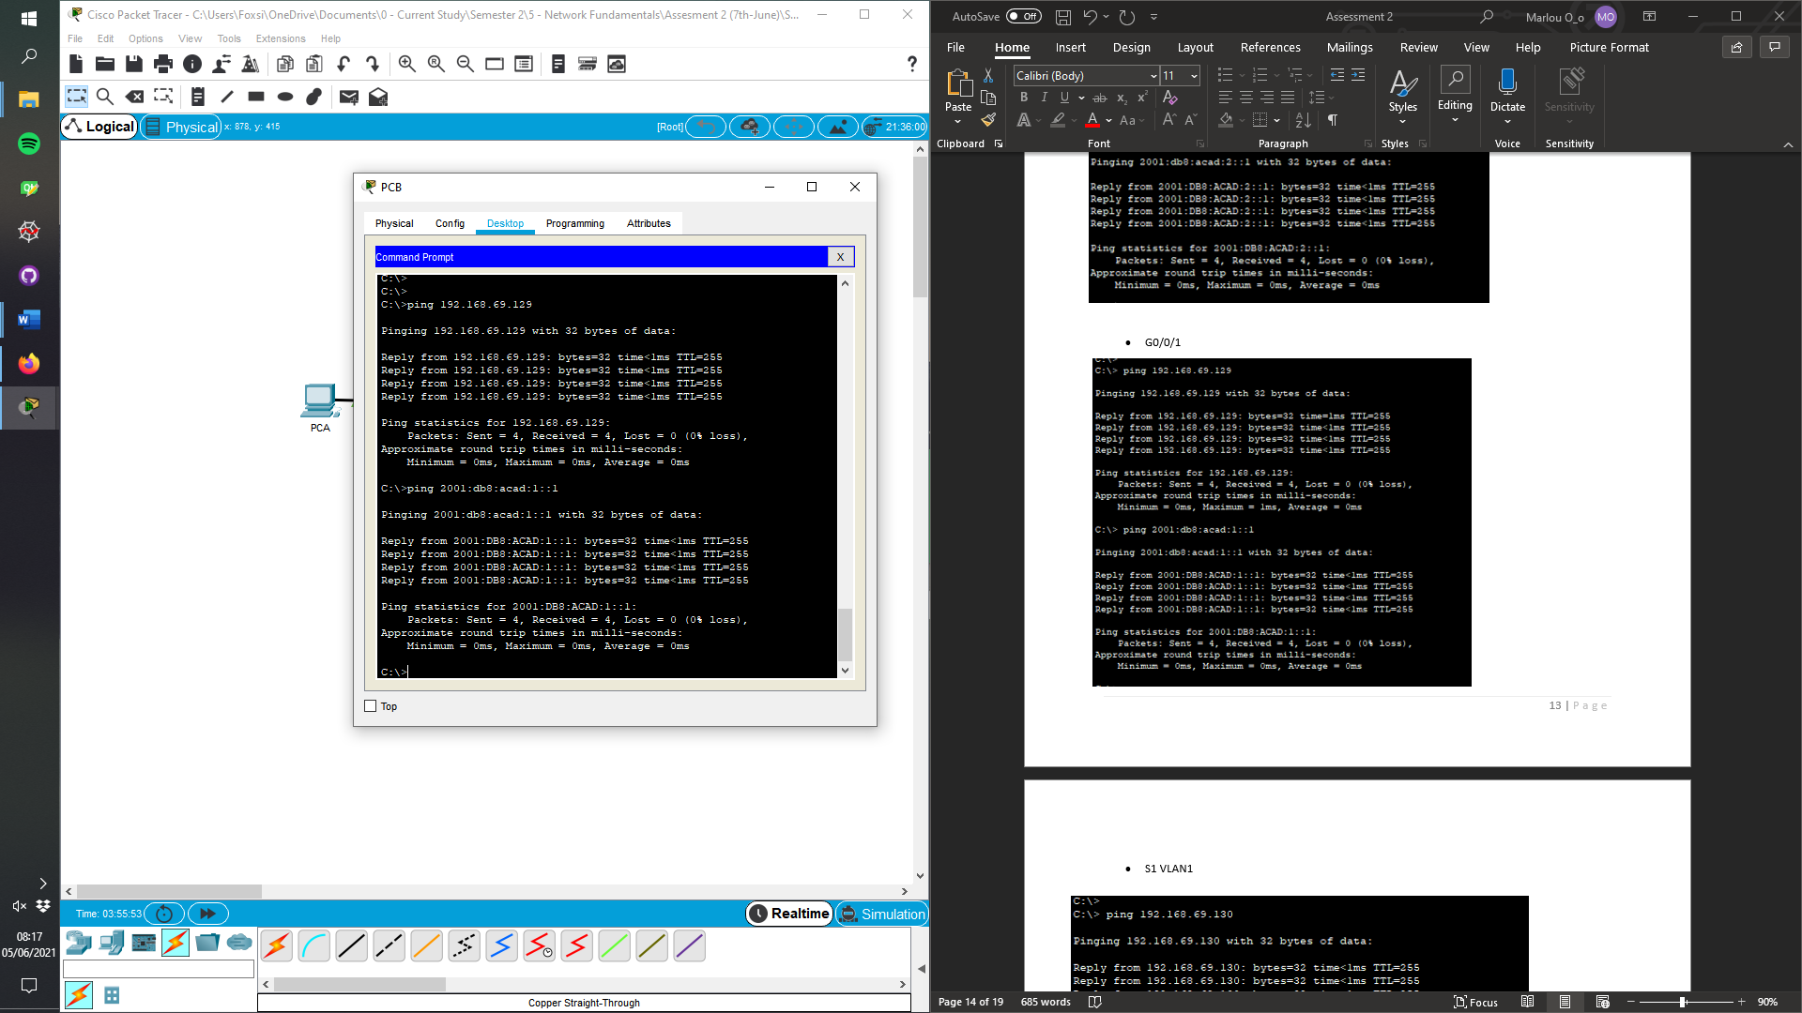G0/0/1
* 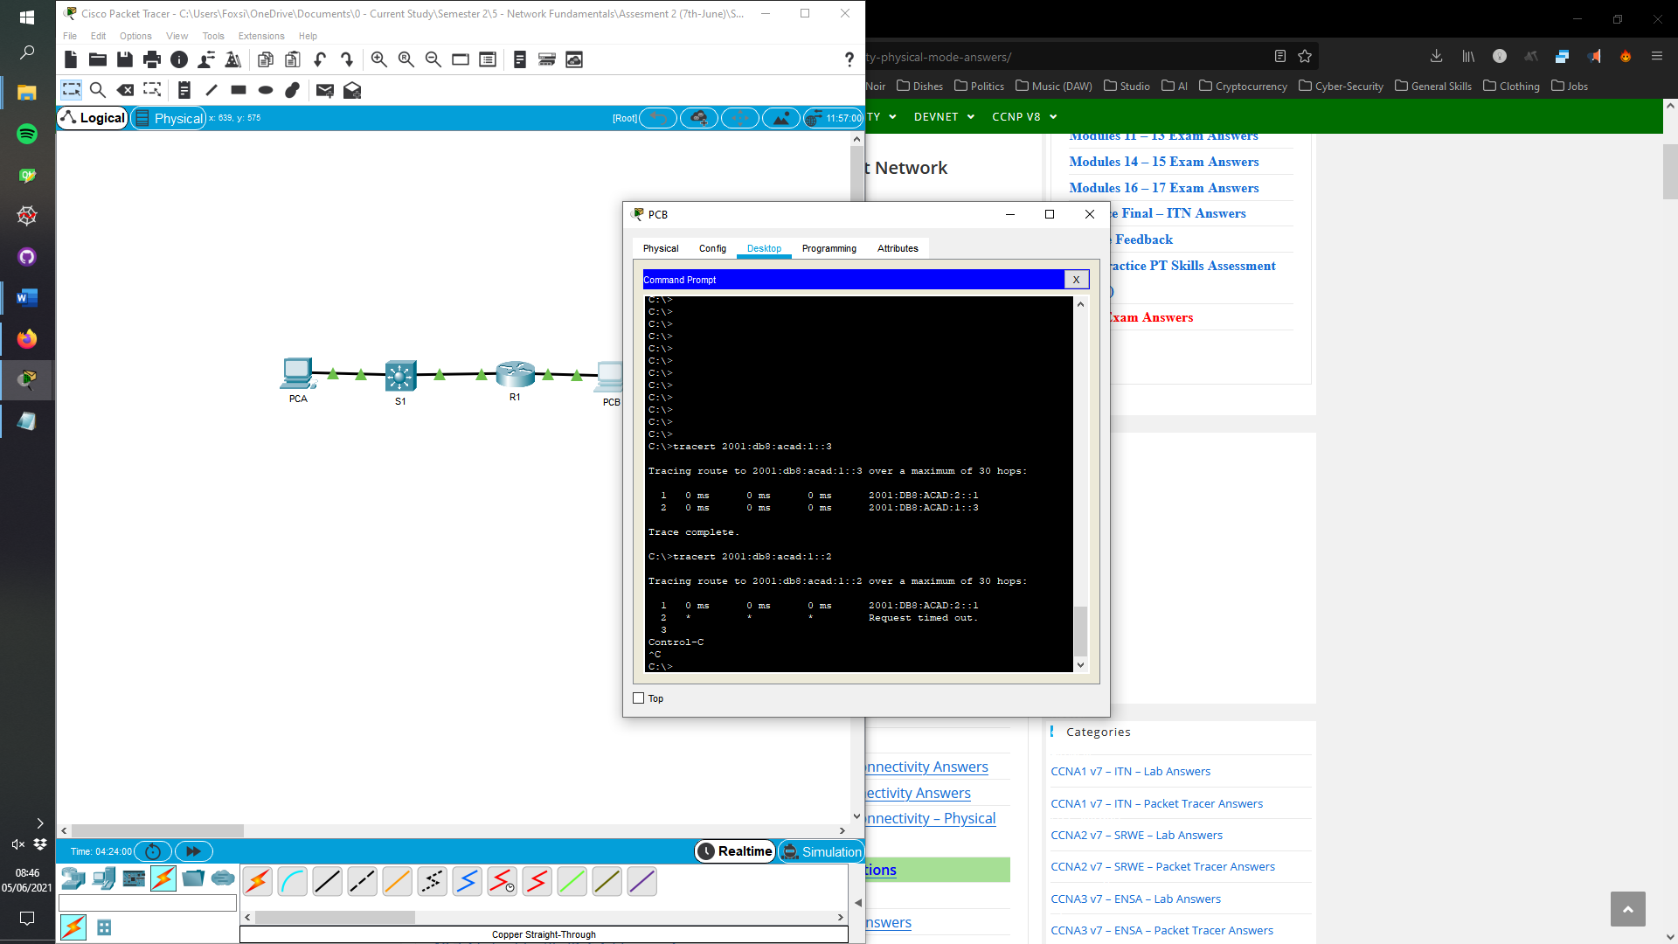S1 VLAN1

For some reason trying to get PC-B to communicate with S1 VLAN1 wasn’t possible. In the screenshot to the right it shows that packets can be sent to the switch from PC-B when in correspondence to PC-A, but for some reason when attempting to communicate with the switch directly the request times out. The IPv4 works fine, but the ipv6 isn’t, if your able to remedy this fault when this is marked, I would be interest to understand why it wasn’t working.

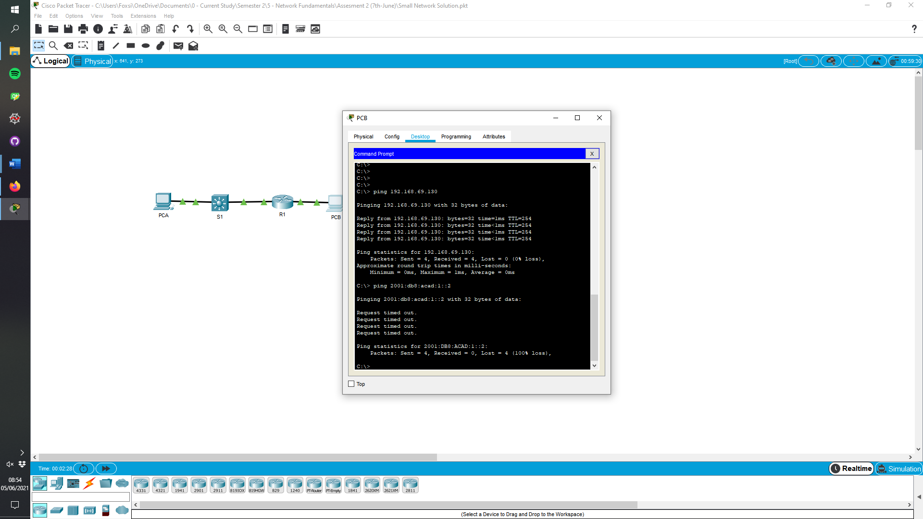Shows the IPv4 is working

Step 2: Appropriate Commands for following Descriptions

| Command Description | Command |
| --- | --- |
| Display a summary of important information about the IPv4 interfaces on R1. | sh ip int br |
| Display the IPv4 routing table. | sh ip route |
| Display the Layer 2 to Layer 3 mapping of addresses on R1. | sh arp |
| Display detailed IPv4 information about interface G0/0/0 on R1. | sh ip int g0/0/0 |
| Display the IPv6 routing table. | sh ipv6 route |
| Display a summary of IPv6 interface addresses and status. | sh ipv6 int br |
| Save the current configuration so it will be used the next time the router is started. | copy running-config startup-config |